Housing Authority of the City of Perth Amboy

881 AMBOY AVENUE, P.O. BOX 390, PERTH AMBOY, NJ 08862
TELEPHONE: (732) 826-3110
FAX: (732) 826-3111

EDNA DOROTHY CARTY-DANIEL, Chairperson DOUGLAS G. DZEMA, P.H.M.
FERNANDO A. GONZALEZ, Vice-Chairman Executive Director
GREGORY PABON
MIGUEL A. AROCHO
DIANE CRAWFORD
WILFREDO SOTO EDWARD TESTINO
DAVID BENYOLA Counsel

Request for Proposals
for
Landscape Maintenance Services
at
Six Public Housing Sites
in
Perth Amboy, New Jersey

Proposals are due by 2:00 PM on Tuesday, February 25, 2025
CONTENTS

Introduction ..……………………………………………………………………………. 3

Notice-Request for Proposals …………………..…………………………………....... 3

Form of Contract…………………………………………………………………………. 4-6

Description of the Housing Project Site……………………………………………….. 7

Specifications, Section 02921 Landscaping …………………………………………. 8-17

Required Proposal Documents:

Proposal Form ………………………..………..…………....……..…….……………… 18-20

Non-Collusive Affidavit …………....……..……….…………………………………..... 21

Qualification Questionnaire ………...…………………………….……..…..…………. 22-23

Perth Amboy Housing Authority
Landscape Maintenance Services 2025

INTRODUCTION

The Housing Authority of the City of Perth Amboy (Authority) is seeking proposals from interested contractors to perform Landscape Maintenance services for the 2025 season as per the Specifications, Section 02921 contained herein at William A. Dunlap Homes, John A. Delany Homes, George J. Otlowski Sr. Gardens, Richard F. Stack Apartments, Wesley T. Hansen Apartments, John E. Sofield Gardens, Douglas G. Dzema Gardens and the Administrative offices located in Perth Amboy, New Jersey.

The work involved in the contract shall not include weekly maintenance (lawn mowing, leaf raking, etc.). Weekly maintenance is a separate contract.

The work involved in the contract shall include specific landscaping services such as the removal and planting of trees, plants and shrubs as necessary, pesticide applications, paver installations, etc., as specifically requested in the technical specifications.

Questions may be submitted in writing to DSabey@PerthAmboyHA.org.

The contract term shall be for the 2025 landscaping season and will not be renewable as the technical specifications change from year to year.

NOTICE – REQUEST FOR PROPOSALS

The Housing Authority of the City of Perth Amboy (Authority) will receive sealed proposals for Landscape Maintenance services at various housing development sites for the 2025 landscaping season. Weekly lawn mowing is not part of this contract.

Proposals will be received until 2:00 PM on Tuesday, February 25, 2025 prevailing time, at the administrative office of the Housing Authority, 881 Amboy Avenue, PO Box 390, Perth Amboy, NJ 08862. The written Request for Proposals (RFP) may be downloaded from the Authority’s website, www.PerthAmboyHA.org. All contract requirements and requirements for the proposal are described in the RFP. The Authority invites the participation of Minority-Owned Business Enterprises in this solicitation and reserves the right to reject any or all offers or to waive any informalities in this solicitation.

Form of Contract (SAMPLE)

Landscape Maintenance Services

This AGREEMENT made this ____ day of March in the year 2025 by and between

(Name of Contractor)
(Address)

hereinafter called the "Contractor,” and the

Housing Authority of the City of Perth Amboy / Hansen RAD, LLC / Dunlap RAD, LLC
881 Amboy Avenue, PO Box 390, Perth Amboy, NJ 08862
THREE Separate Contracts Shall Be Issued

hereinafter called the "Authority".

WITNESSETH that the Contractor and the Authority for the consideration stated herein mutually agree as follows:

Article 1. Statement of Services. The Contractor shall furnish all labor, materials, tools and equipment and shall perform and complete all work required for landscape maintenance services.

Article 2. Term of Contract. This contract shall extend for a period of 9 months from signing of contract.

Article 3. Scope of Work.

        - Provide landscape maintenance of trees, plants and shrubs and planting areas at the following sites:
          - William A. Dunlap Homes and Management Offices
          - George J. Otlowski Jr. Gardens
          - Douglas G. Dzema Gardens
          - John E. Sofield Gardens
          - Richard F. Stack Apartments
          - Wesley T. Hansen Apartments

Article 4. Performance of Work, Work Requirements and Contractor’s Responsibility. The Authority shall have the sole right and discretion to order work under his contract. The Authority reserves the right to award work of a similar nature, through other procurement methods, to other contractors.

The Contractor shall be responsible for furnishing all materials, equipment, labor and transportation necessary to perform the work.

The Contractor shall not sub-contract any work under this contract without express prior written approval of the Authority.

Contractor will schedule and perform the work between the hours of 8:00 a.m. to 4:30 p.m., Monday through Friday, unless prior written permission is granted by the Authority to perform work at other times. The Contractor shall coordinate all his activities with the Authority. The Authority may charge to the contractor any additional costs for inspections or testing.

The Contractor shall at all times keep the work area orderly and free from accumulations of waste materials. After completing the work, the Contractor shall remove all equipment materials and tools that are not the property of the Authority and leave the work area in a neat, clean and orderly condition. The Contractor shall dispose of all debris off-site in accordance with all applicable Federal, State and local statutes, ordinances and regulations.

The Contractor shall be responsible for all damages to persons or property that occur as a result of the Contractor’s fault or negligence, and shall take all necessary health and safety precautions to protect the work, the workers, the public, and the property of others. The Contractor shall hold and save the Authority, its officers and agents, free and harmless from liability of any nature occasioned by the Contractor’s performance.

The Contractor shall apply and pay for any applicable permits related to the work. Fees for Building permits issued through the City Code Enforcement office are waived. No final payments shall be processed without furnishing written documentation the work has been inspected and the City of Perth Amboy has closed out the permit.

Article 5. Contract Prices and Payments. The Authority shall make payment to the Contractor in accordance with the prices bid by the Contractor via the Bid Proposal Form, hereunto included herein by reference and made a part hereof. The Authority shall make payments upon the completion of work by the Contractor and the presentation of an invoice. Separate invoices shall be submitted for each company: Perth Amboy Housing Authority, Dunlap RAD, LLC and Hansen RAD, LLC. Payments shall be made within 30 days of receipt of the invoices by the Authority.

Article 6. Insurance. Before performing any work, the Contractor shall furnish the Authority (separate certificates for each company) with certificates of insurance showing the following insurance is in force and will insure all operations under the Contract:

- Workers’ Compensation, in accordance with New Jersey Workers' Compensation laws.
- Commercial General Liability with a combined single limit for bodily injury and property damage of not less than $1,000,000.00 per occurrence to protect the Contractor and the Authority against claims for bodily injury or death and damage to the property of others. This shall cover the use of all equipment, hoists, and vehicles on the site(s) not covered by Automobile Liability under (3) below. If the Contractor has a “claims-made” policy, then the following additional requirements apply: the policy must provide a “retroactive date” which must be on or before the execution date of the Contract, and the extended reporting period may not be less than five years following the completion date of the Contract.
- Automobile Liability on owned on owned and non-owned motor vehicles used on the site(s) or in connection therewith for a combined single limit for bodily injury and property damage of not less than $500,000.000 per occurrence.

All Insurance shall be carried with companies, which are financially responsible and admitted to do business in the State of New Jersey. If any such insurance is due to expire during the construction period, the Contractor shall not permit the coverage to lapse and shall furnish evidence of coverage to the Authority. All certificates of insurance, as evidence of coverage, shall provide that no coverage may be canceled or non-renewed by the insurance company until at least 30 days prior written notice has been given to the Authority.

Article 7. New Jersey Business Registration Requirements. The contractor shall provide to the Authority proof of the contractor’s business registration with the New Jersey Division of Taxation before contract award.

Article 8. Contract Documents. Contract Documents shall consist of the following component parts:

- This instrument;
- Request for Proposals dated February 25, 2025
- Proposal submitted by the Contractor dated February 25, 2025.

This instrument together with the document enumerated in this Article form the Contract, and they are fully a part of the Contract as if hereto attached or herein repeated. In the event that any provision in one of the component parts of the Contract conflicts with any provision of any other component part, the provision in the component part first enumerated in this Article shall govern, except as otherwise specifically stated.

IN WITNESS WHEREOF, the parties hereto have caused this instrument to be executed the date and year first above written.

In the presence of:

____________________________________ by_______________________________________
(Name)
(Title)
(Company Name)
(Phone Number)
In the presence of:

_____________________________________ by______________________________________
Douglas G. Dzema, PHM
Executive Director
Housing Authority of the
City of Perth Amboy

Description of the Housing Project Sites

Billed Separately as Housing Authority of the City of Perth Amboy:

Management Offices: 881 Amboy Avenue, William A. Dunlap Homes
Management office building and parking lot

Billed Separately as Dunlap RAD, LLC:

William A. Dunlap Homes, Zambory Street
(17) 2-story, garden apartment bldgs.

George J. Otlowski Jr. Gardens, Dobranski Street
(4) 2-story garden apartments
- Single - story Community Room
Playground and parking lot

Douglas G. Dzema Gardens
(8) Detached townhouses

John E. Sofield Gardens
(9) Detached townhouses

Billed Separately as Hansen RAD, LLC:

Wesley T. Hansen Apartments, 415 Fayette Street
11- story high-rise
Parking lot

Richard F. Stack Apartments, 333 Rector Street
6-story high-rise
Parking lot

2025 Landscaping Specifications
Part 1 General

Related Documents

Drawings and general provisions of Contract, including General and Supplementary Conditions, apply to this Section.

Summary
This section specifies administrative and procedural requirements for submittals required
and performance of Work, including:

Clean Fill

Final grade

Topsoil

Seed

Soil Erosion Control

Weed Control

Fertilizing

Mulch Triple shredded, cedar

Submittals

Type of clean fill to be used.

Type of topsoil to be used.

Grass mix design.

Granular Chemical products for fertilizing and weed control.

Trees.

Shrubs.

Part 2 Products

Topsoil that is fertile, friable, natural loam, reasonably free of subsoil clay lumps, rocks
and any material toxic to plant life.

Grass Material is to be fresh, clean new crop seed. Provide a seed mixture applicable to this region that will have a minimum germination of 75%.

Fertilizer: Granular, Scotts - Ornamental shrub food - 14-14-14 or equal.

Weed Control: Granular, Treflan or equal.

Trees/Shrubs: To be provided per the listed plant schedule. Contractor shall provide unit prices for all listed plants/trees/pavers in the event the Owner directs the contractor to perform additional plant/shrub/tree installations. Contractor shall identify where the trees and shrubs are purchased to allow the Owner the opportunity to inspect them before the contractor purchases them. The following list indicates the species and size of plant.

Wichita Blue Juniper - 4’-5’

Taxis Cuspidata Intermedia - 24”-30” Dwarf Japanese Yew

Gold Mop Cypress - 18”- 24”

Bradford Pear - 2-1/2” - 3” caliper

Procumbus Nana Juniper - 18”- 24” spread (2-gal.)

Vinca Flowers - Flats (minimum of 18 plants in a flat)

Barberry - 5-gal

Winter King Hawthorn - 2-1/2”- 3” caliper

Northern Red Oak - 2-1/2”- 3” caliper

Schedule: Planting and Cleanup:

Note: Shrub/trees listed in this schedule are part of the lump sum contract. Unit prices for plants are for where the Owner elects to plant additional products.

Note: All specified trees or shrubs schedule for planting shall be planted during the Spring cycle. The contract is for two cycles of maintenance. Cycle 1 by June 1, 2025 - Cycle 2 by October 3, 2025. The contractor shall perform all the work outlined for each Work Site defined in this document during Cycle 1. Cycle 2 will be comprised of performing maintenance of the items being completed in Cycle 1, which will include, but not be limited to, weeding, cleaning, seeding, light pruning and light mulch freshening. The contractor is expected to start and complete the work in each of the two cycles as soon as possible.
Plantings and other work as specified: To be installed in Cycle 1 (include all labor and material costs in base bid)

For the proposal and for billing for completed services contractors shall follow the following procedures:

Contractors shall submit one bid for all the work, broken down into three independent pricing and billing components as follows:

- Management Offices; Perth Amboy Housing Authority, 881 Amboy Avenue, Perth Amboy, NJ.

- Richard F. Stack Apartments, 333 Rector Street, Perth Amboy and Wesley T. Hansen Apartments, 415 Fayette Street, Perth Amboy: Hansen RAD LLC, 881 Amboy Avenue Perth Amboy NJ.

- William A. Dunlap Homes, Lautenberg Center, Douglas G. Dzema Gardens and Sofield Gardens: Dunlap RAD LLC , 881 Amboy Avenue, Perth Amboy, NJ.

Work Sites:

- Perth Amboy Housing Authority: Management Offices:

Trim shrubs and ornamental trees and clean the planting beds. Add mulch as required to maintain weed control. Apply weed control and fertilizer.
Areas of work:

General: The entire grounds of the Administration/Section 8 offices which is bordered by a fence on 3 sides.

Admin Offices:

- Plant 36pcs of (Vinca) flowers to form a border in the courtyard. Flower colors to be selected by Owner.
- The mulch in the courtyard area shall be cleaned out and large mulch pieces removed and the remainder turned over into the soil and a thin layer of new mulch applied on top.
- Clean, weed and replenish stone mulch (3/8”) barrier along the perimeter of the office building continuous from the rear corner of Section 8 Office and Administrative Office parallel to Zamboy Street and on the side of the building facing Amboy Ave. Strip shall be contiguous. Approximate length 275ln. ft. by 2’-0” wide x 1” deep. Rake out deleterious material and add ½” -1” depth of 3/8” stone.
- Clean the island area of the entrance to the parking lot when post sign is located. Add mulch to island.
- Trim shrubs, remove leaves and clean and mulch the retaining wall planting areas behind the office and at rear of parking lot.
- Mulch planting bed along fence line at the corner of Amboy Avenue & Zambory Street.
- Clean & mulch all tree wells on the property.
- Grind stump located at the back of the building inside the fence line on Zambory Street.

- Dunlap RAD LLC:

William A. Dunlap Homes:
General:

- Clean & mulch the front (street side) of Buildings A, E, F, G, H, J, M & N, the rear area of Building C and the sides of Buildings E & G that face the traffic circle.
- Clean & mulch the contiguous areas around and between Buildings BB, V, W, and X where there are planting beds, including the sidewalk area parallel to Amboy Avenue in front of BB Building and over to X Building.
- Clean & mulch the planted areas in front, behind and adjacent to the Dunlap Homes Monument sign at the corner of Pfeiffer Blvd. and Amboy Avenue.
- Clean & mulch the planting area on the opposing corners where Zambory Street intersects Waltrous Avenue.
- Clean & mulch all tree wells along Zambory Street and sidewalk leading to Otlowski Gardens between Buildings L & K. Prune all foundation plants and mulch planting beds.
- Trim all dead fall and prune all trees.
- Provide tree well mulch beds for all Small Trees as defined herein where they do not already exist. Refurbish all existing tree well mulch beds.

Building BB along Pfeiffer Blvd.:

- There are two raised beds in front of the Dunlap Homes Monument Sign:
  - Plant flats of (Vinca) in each area. Minimum of 16 plants per bed.

Building V:

- Clean out stone mulch along foundation and place an additional ½”-1”, minimum, of 3/8” stone.

Building W:

- Clean out stone mulch along foundation and place an additional ½”-1”, minimum, of 3/8” stone.

Building X:

- Clean out stone mulch along foundation and place an additional ½”-1”, minimum, of 3/8” stone.

George J. Otlowski Gardens

- Trim shrubs, clean and wood mulch all planting beds on this site.
- Trim shrubs, clean and wood mulch retaining walls by the Lautenburg Center.
- Trim shrubs, clean and wood mulch planting beds around the Lautenburg Center.
- Clean & mulch all tree wells along Convery Boulevard and on the property.
- Trim all dead fall and prune all small trees on property.
- Grind stumps (two total) located in front of Units 302 & 401.

Douglas G. Dzema Gardens

- Trim shrubs, clean and wood mulch all planting beds in all areas around the buildings.
- Trim all dead fall and prune all small trees on property.
- Clean & mulch all tree wells on the property.

John E. Sofield Gardens

- Trim shrubs, clean and wood mulch all planting beds in all areas around the buildings.
- Trim all dead fall and prune all small trees on property.
- Clean & mulch all tree wells on the property.
- Grub stump on Cortland street in front of Unit 645.

- Hansen RAD LLC:

Wesley T. Hansen Apartments: 415 Fayette Street:

- Trim shrubs, clean and mulch planting beds located at the rear and driveway side of the building.
- Trim shrubs, clean and mulch planting beds located on the Fayette Street side of the building.
- Mulch each of [3] brick planters at front of building.
- Monument Sign: Clean out and weed and apply mulch. Plant 6pcs of (Vinca) flowers.
- Trim all dead fall and prune all small trees on property.
- Clean & mulch all tree wells on the property.
- Grind two stumps on hillside by parking lot.
- Grub two stumps on the backside of the parking lot by the entrance.

Richard F. Stack Apartments: 333 Rector Street

- Trim shrubs, clean and mulch all plant areas, on the site, facing Rector Street and Fayette Street and all the landscaping plant areas in the rear fenced in yard.
- Trim shrubs, clean and mulch planting beds located on the Rector Street side of the building. Add muck planting bed along front face of building on Rector street, 3’ deep, and plant eight (8) Gold Mop Cypress.
- Trim shrubs, clean and mulch planting beds located in back fenced area of the building.
- Trim all dead fall and prune all small trees on property.
- Clean & mulch all tree wells on the property.

Part 3 Execution

Preparation - General

Site Familiarity this contractor shall be responsible for familiarizing themselves with all existing site conditions prior to submitting their proposal to determine the extent of work outlined at the Work Sites defined in this request.
(a) The Contractor acknowledges that it has taken steps reasonably necessary to ascertain the nature and location of the work, and that it has investigated and satisfied itself as to the general and local conditions which can affect the work or its cost, including but not limited to, (1) conditions upon transportation, disposal, handling, and storage of materials; (2) the availability of labor, water, electric power, and roads; (3) uncertainties of weather, river stages, tides, or similar physical conditions at the site; (4) the conformation and conditions of the ground; and (5) the character of equipment and facilities needed to and during work performance. The Contractor also acknowledges that it has satisfied itself as to the character, quality, and quantity of surface and subsurface materials or obstacles to be encountered insofar as this information is reasonably ascertainable from an inspection of the site, including all exploratory work done by the Client, as well as from the drawings and specifications made a part of this contract. Any failure of the Contractor to take the actions described and acknowledged in this paragraph will not relieve the Contractor from responsibility for estimating properly the difficulty and cost of successfully performing the work, or for proceeding to successfully perform the work without additional expense to the Client.

(b) The Client assumes no responsibility for any conclusions or interpretations made by the Contractor based on the information made available by the Client. Nor does the Client assume responsibility for any understanding reached or representation made concerning conditions which can affect the work by any of its officers or agents before the execution of this contract, unless that understanding, or representation is expressly stated in this contract.

Remove weeds, grass and other unsuitable and deleterious materials from the planting beds. Remove all existing mulch in preparation for new mulch.

Cut burlap or other wraps and loosen soil around new plant root balls

Remove dead plants: Note: The Housing Authority shall approve of all shrub removals performed by the contractor if the contractor expects to be compensated for a new plant that was not specified in the contract. The Housing Authority will only reimburse contractor for plantings identified by the HA for replacement. Replacements of dead plants are in addition to the specified quantities to be planted. Replacements shall be invoiced based on the unit prices provided by the contractor and included in the proposal.

Top Soil: Spread to a minimum depth of four inches, or as required maintaining lines and grades.

Seeding New Lawns: Sow seed using a hydro-seeding machine and ensure uniform spreading of material. Protect newly seeded areas from erosion. Apply straw over new seed to protect seed and retain moisture. Contractor is required to seed all areas identified on the drawings and all other areas disturbed by the contractor in the execution of his work. Apply seed multiple times or until lawn is established.

Steep grades will require burlap staked into the ground or other means to bind the soil and seed until the lawn is established.

Reconditioned Lawns: Existing areas damaged by the Contractor, during the course of his work, are to be re-graded and seeded to restore to previous condition.

Replace dead Shrubs and install a plant similar in size and species in the listed schedule. Provide new topsoil around all new plantings without exception. Holes where shrub is planted shall be twice the diameter of the ball and filled with topsoil.

Prune all bushes and trees in planting areas. Aggressively trim back shrubs to prevent over growth in the planting bed and to keep growth away from building walls and from other structures.

Remove all burlap, in its entirety, from the root ball and prior to planting.

See planting details for instructions on how to prepare holes, plant and stake trees/shrubs. Trees holes shall be prepared to a depth that the ball of the tree is not above the existing grades.

Mulch all planting beds after they have been cleaned. Apply a minimum of 1/2” of wood or stone mulch to all areas. Bare spots shall receive up to maximum of 2” of mulch. Cycle 2 may require less new mulch product. Do not over mulch.

Apply weed and grass control on the soil and before mulching. Apply at the manufacturer’s suggested rates. Prevent over application outside the landscape bed.

Apply a suitable granular shrub food around all plantings. Apply at the manufacturer’s suggested rate.

Cleanup and Protection

- During landscape work, keep walkways and streets clean.
- Maintain soil erosion controls.
- Clean up debris at the end of each workday.

Sweep granular chemicals off sidewalks after fertilizing

Detailed Specifications Small Tree Maintenance & Grinding
1. Scope of work: one company to provide all labor, supervision, equipment, services, and expertise required to perform small tree maintenance on specified trees on client’s property as specified herein. Work consists of arboricultural care of trees primarily between 1 and 6 inches in diameter. Work to be performed by a contractor which earns a majority of its annual revenue by performing landscape and tree service work, and which shall be qualified by reference and past experience demonstrating employees are highly trained and skilled in all phases of arboricultural work, such as pruning, watering liquid fertilization, guying, mulching, and replanting, and have familiarity with tree service work standards of the National Arborist Association (NAA) and Safety And Pruning Standards Of The American National Standards Institute (ANSI).
2. Standards:
A. NAA Standards - the most current revision of the national arborist association standards for pruning of shade trees, guying of shade trees, fertilizing shade and ornamental trees, and pesticide application operations.
B. ANSI A300 - the most current revision of the American National Standard - "Standard Practices For Trees, Shrubs And Other Woody Plant Maintenance" which apply to pruning done under this contract.
C. ANSI Z133.1 - the most current revision of the American National Standards For Tree Care Operations - Safety.
Item 1 - Pruning
Contractor will be assigned to prune trees less than 6 inches in diameter in specific areas of the property. These trees have normally been planted within the last 2 to 10 years.
A.1. Pruning of young trees (3-6 years after planting, and up to 6 inches in diameter)
A. Small trees pruned to develop a strong scaffold structure.
B. Contractor prunes to maintain or develop a strong central leader (excurrent branch habit), and prunes out crossing branches and limbs or stems with included bark. Small trees also pruned to provide as much street and sidewalk clearance as possible without adversely affecting the vitality of the tree. A live crown ratio of at least 50% on each tree must remain after pruning. Only manual tools shall be used on trees less than 6 inches in diameter at breast height (4.5 feet). All saws must have a hollow ground, tri-cut blade. Only by-pass type pruners shall be used. Trees recently pruned (within 2 years) may not be assigned to contractor.
Pruning conforms to ANSI A300 standards - Part 3.5 (Young Tree Pruning). Pruning includes removal of all basal sprouts and any weeds, brush, or vines growing within 2 feet of the tree’s trunk. The client may direct contractor to prune trees to maintain or establish clearance for sidewalks, lights, signs, buildings, or other association installations. Standards for street and sidewalk clearance are 14 and 8 feet, respectively, or in the case of small trees, up to half the tree’s height. Such work must be balanced with the desire to maintain the character and health of the tree. Hand pruning tools and saws are to be used on trees. No power saws are permitted. All tools are cleaned after work on each tree. Basal or sucker sprouts, after being removed, will be treated with a sprout-inhibiting product supplied at contractor’s expense.
Contractor is required to clean up site and dispose of all debris. Site clean-up must be completed within 2 hours after completion of each pruning. The site is left as clean or cleaner than pre-work conditions as soon as possible.
Item 2 - Mulching
Contractor will be assigned to mulch trees less than 6 inches in diameter. Trees will be mulched by uniformly placing mulch around trees to a diameter of 4 feet where possible and to a depth of 6 inches for rough wood chips and no more than 2 inches for processed hardwood bark mulch products. Mulch shall not be placed directly against trunk. The client reserves the right to reject mulch of poor quality.
Item 3 - Grinding

Stump grinding specifications: for stump grinding not associated with a tree removal, stumps will be ground out to a depth of 6 inches below the normal surface level including all surface roots. Immediately after grinding each stump, the grindings must be removed from the work area. Adjacent sidewalks, lawns, streets, and gutters will be cleaned. Holes are not to be left open overnight. Backfill consisting of clean earthen soil should be used to fill in the cavity, free of debris, to 4 inches above the existing lawn grade surrounding the stump site (to allow for settling) and seeded with an approved seeding mix. Do not backfill with wood chips.

Warranty

The contractor shall provide a one (1) year for replacement of any shrub or tree planted by the contractor. The warranty shall be without limitation on why the plant has died and the contractor shall replace the plant with the same species and caliber without charge to the Housing Authority.

End of Section

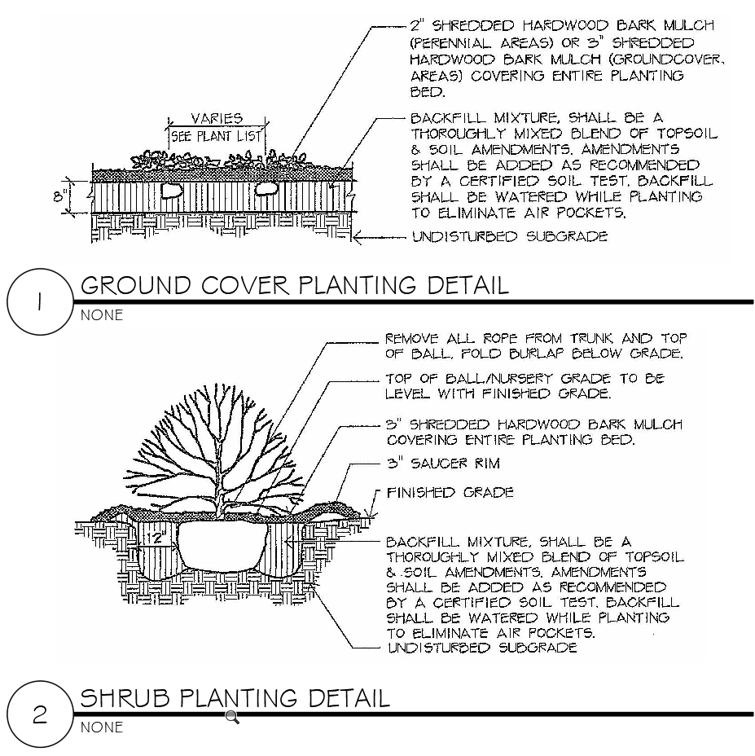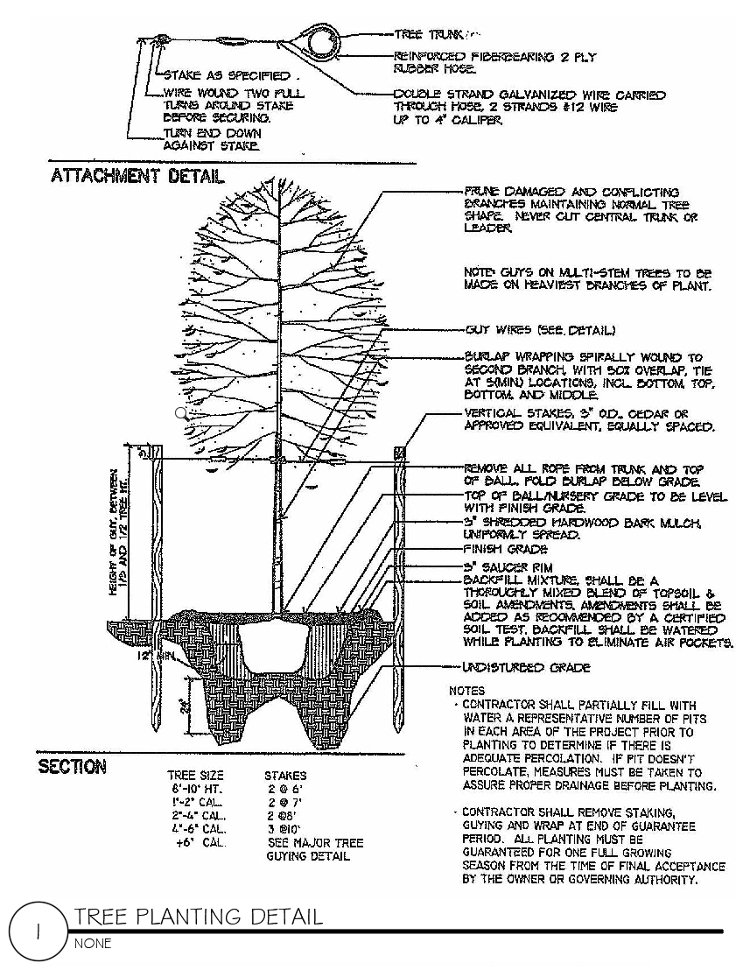

Proposal Form

Proposal for: Landscape Maintenance Services

TO: Housing Authority of the City of Perth Amboy, 881 Amboy Avenue, Perth Amboy, NJ 08862

FROM:
_____________________________________________________________________
Company Name of Bidder Federal ID#
_____________________________________________________________________
Street Address
_____________________________________________________________________
City, State - Zip Code
_____________________________________________________________________
Contact Name and Telephone Number
_____________________________________________________________________
Fax Number / Email Address

1. The undersigned, having read the specifications, including the Request for Proposals, the form of contract, contract conditions, description of the project sites and equipment, this proposal form, the form of non-collusive affidavit, the form of statement of offeror’s qualifications, the Certifications and Representations of Offerers, and addenda, if any, thereto, and having investigated the local conditions affecting the cost of the work, hereby propose to furnish all labor, materials, services, equipment and related items to complete all work for landscape maintenance services at the following prices:

      - Perth Amboy Housing Authority: Administrative Offices:

A. Spring (Cycle 1) Landscape Maintenance Services:

_______________________________________________dollars and _______ cents ($______.___)
B. Autumn (Cycle 2) Landscape Maintenance Services:

_______________________________________________dollars and _______ cents ($______.___)
C. Total Base Services (Sum of A & B):

_______________________________________________dollars and _______ cents ($______.___)
      - Dunlap RAD, LLC:

A. Spring (Cycle 1) Landscape Maintenance Services:

_______________________________________________dollars and _______ cents ($______.___)
B. Autumn (Cycle 2) Landscape Maintenance Services:

_______________________________________________dollars and _______ cents ($______.___)

C. Total Base Services (Sum of A & B):

_______________________________________________dollars and _______ cents ($______.___)
      - Hansen RAD, LLC:

A. Spring (Cycle 1) Landscape Maintenance Services:

_______________________________________________dollars and _______ cents ($______.___)
B. Autumn (Cycle 2) Landscape Maintenance Services:

_______________________________________________dollars and _______ cents ($______.___)
C. Total Base Services (Sum of A & B):

_______________________________________________dollars and _______ cents ($______.___)
Unit Prices for additional plantings including labor and materials:
      - Wichita Blue Juniper, 4’-5’__________________________dollars and _______ cents ($______.___)
      - Taxis Cuspidata Intermedia - Dwarf Japanese Yew, 24”-30” ______________________dollars and _______ cents ($______.___)
      - Gold Mop Cypress, 18”-24”’_________________________dollars and _______ cents ($_____.___)
      - Bradford Pear, 2½ “-3” caliper ___________________dollars and _______ cents ($_____.___)
      - Procumbus Nana Juniper, 18”-24” spread (2 gal.) ______________dollars and _______ cents ($___.___)
      - Vinca Flowers (min. of 18 plants in a flat) _____________________dollars and _______ cents ($___.___)
      - Lantana Flowers: _____________________________________dollars and ________cents ($____.___)
      - Barberry, 5 gallon ______________________________________dollars and _______ cents ($____.___)
      - Winter King Hawthorn, , 2½ “-3” caliper _____________________dollars and _______ cents ($____.___)
      - Northern Red Oak, , 2½ “-3” caliper _____________________dollars and _______ cents ($______.___)
      - Paving Stone: Cambridge, Amortec, Renaissance, Ruby/Onyx, per square foot ________________________dollars and _______ cents ($___.___)

2. The offeror acknowledges the receipt of the following addenda, if any, issued by the Authority:
Addendum Number __________ dated ___________________________

3. The names and address of persons interested as principals or as stockholders in this Proposal are as follows. (If the offeror is a corporation or partnership, list all persons who have 10 percent or more ownership in the corporation or partnership.)

______________________________________________________________________________
Full Name Address % of ownership
______________________________________________________________________________
Full Name Address % of Ownership
______________________________________________________________________________
Full Name Address % of ownership

The offeror shall state on the line below, whether or not he is a citizen of the United States, and in the case of a partnership, whether or not all partners are citizens of the United States.

________________________________________________________________________________

4. This Proposal is accompanied by:

(1) Non-Collusive Affidavit;
(2) Qualification Questionnaire.
(3) New Jersey Business Registration Certificate.

5. In submitting this proposal, it is understood that the Authority reserves the right to reject any and all proposals.

____________________________________________________ ________________________
Signature of Offeror - Title Date

Non Collusion Affidavit

AFFIDAVIT

State of ________________________

County of ______________________

___________________________________________________ being first duly sworn deposes and says:
(Individual’s Name)

THAT he is ____________________________________________________________________ of
(Owner, Officer or Partner)

________________________________________________________________________________
(Firm Name)

the party making the foregoing proposal dated February 25, 2025 for landscape services; that such proposal is genuine and not collusive or sham; that the offeror has not colluded, conspired, connived or agreed, directly or indirectly, with any offeror or person, to put in a sham offer or to refrain from offering a proposal, and has not in any manner, directly or indirectly, sought by agreement or collusion, or communication or conference with any person, to fix the offered price of affiant or of any offeror, or to fix any overhead, profit or cost element of said proposed price, or of that of any other offeror, or to secure any advantage against the Housing Authority of the City of Perth Amboy or any person interested in the proposed contract; and that all statements in the said proposal are true.

________________________________________________
(Signature of Offeror)

Subscribed and sworn to before me, this ______ day of ____________, in the year ___________

____________________________________________________
Notary Public

My Commission expires __________________

Qualification Questionnaire
Proposal for: Landscape Maintenance Services

Name of Bidder: __________________________________________________________________

Address:________________________________________________________________________

________________________________________________________________________________

(a) It shall be necessary for the offeror to present evidence that he has been in business for at least 2 years in this field and can submit a suitable record of satisfactorily completing similar contracts.

How many years have you been or engaged in business under your present firm or trade name?

________________Years.

(b) How many years has your organization been performing the work required under this contract?

________________Years.

(c) If a corporation, answer the following:

Date of incorporation: ______________________________________________________________

State of Incorporation: ______________________________________________________________

President's Name: _________________________________________________________________

Vice President's Name(s):___________________________________________________________

(d) If a partnership, answer the following:

Date of Organization:_______________________________________________________________

(e) List New Jersey Licenses, if any, numbers and effective dates (include Home Improvement Contractor, Pesticide Applicator Licenses):

________________________________________________________________________________

________________________________________________________________________________

________________________________________________________________________________

(f) If the contract is awarded to your firm, who will personally supervise the work?

________________________________________________________________________________
(g) Are there any liens of any character filed against your company at this time? If so, specify the nature and amount of the lien.

________________________________________________________________________________

(h) Give trade references:
________________________________________________________________________________

________________________________________________________________________________

(i) Give bank references:
________________________________________________________________________________

________________________________________________________________________________

(j) Give full information concerning all of your contracts in progress or completed within the last 3 years, whether private or government contracts.

OWNER/LOCATION DESCRIPTION CONTRACT AMOUNT

________________________________________________________________________________

________________________________________________________________________________

________________________________________________________________________________

State of ________________________ County of ______________________

_____________________________________________ being first duly sworn deposes and says:
(Individual’s Name)

THAT he is __________________________________________________________________ of
(Owner, Officer or Partner)
______________________________________________________________________________
(Firm Name)
and that he hereby authorizes and requests any person, firm or corporation to furnish any information requested by the Housing Authority of the City of Perth Amboy in verification of the recitals comprising this Statement of Offeror's Qualification; and that all answers to the foregoing questions and all statements therein contained are true and correct.

________________________________________________
(Signature of Offeror)

Subscribed and sworn to before me, this ______ day of _____________, in the year ___________

____________________________________________________
Notary Public
My Commission Expires

________________________

