Housing Authority of the City of Perth Amboy

881 AMBOY AVENUE, P.O. BOX 390, PERTH AMBOY, NJ 08862
TELEPHONE: (732) 826-3110
FAX: (732) 826-3111

EDNA DOROTHY CARTY-DANIEL, Chairperson DOUGLAS G. DZEMA, P.H.M.
FERNANDO A. GONZALEZ, Vice-Chairman Executive Director
MIGUEL A. AROCHO
DAVID BENYOLA
GREGORY PABON EDWARD TESTINO
WILFREDO SOTO Counsel
DIANE CRAWFORD

REQUEST FOR PROPOSALS
for
ELEVATOR MAINTENANCE
AND REPAIR SERVICES
at
Richard F. Stack Apartments
and
Wesley T. Hansen Apartments

PERTH AMBOY, NEW JERSEY

Proposals due by Tuesday, August 19, 2025 at 2:00 PM

CONTENTS

Cover Page ………………………………………………………………………………. 1

Table of Contents ……………………………………………………………………….. 2

Introduction……………………………………………………………………………… 3

Public Notice………………….…………………....……………………..……………… 3

Instructions to Offerers, Non-Construction, form HUD-5369-B ….…………………… 4-5

Form of Contract..………..…………………..………………………...…….………….. 6-7

Technical Specifications for Maintenance and Service of Three Elevators ………..……. 8-16

Inspection of the Sites and Equipment …………………………………….…………….. 17

Submission of Proposals …………………………………………………...…………….. 17

Selection Procedure and Selection Criteria ………………………………………………. 17

Required Proposal Documents:

Proposal Form ………………………..…………………………………....………….…. 18-19

Non-Collusive Affidavit …………....……..……….……………………………………. 20

Qualification Questionnaire ………...………………………………………..…………... 21-22

Certifications and Representations of Offerors, Non Constr, form HUD-5269-C ............ 23-24

Additional Information

General Conditions for Non-Construction Contracts, form HUD-5370-C II………….. 25-27

PERTH AMBOY HOUSING AUTHORITY
REQUEST FOR PROPOSALS
ELEVATOR MAINTENANCE AND REPAIR SERVICES

INTRODUCTION - The Housing Authority of the City of Perth Amboy (Authority) requests proposals from qualified elevator maintenance and repair companies to perform elevator maintenance and “as-needed” repair services at two housing projects in Perth Amboy, New Jersey (3 elevators total). One elevator is located in Stack Apartments at 333 Rector Street in Perth Amboy, NJ and two elevators in Hansen Apartments located at 415 Fayette Street in Perth Amboy, NJ. Technical specifications are located herein.

The Authority is soliciting a monthly flat rate to perform monthly maintenance on all three elevators and an hourly rate plus a percentage mark-up on materials for all work not included in monthly maintenance. The Authority is also soliciting a flat rate to perform load test(s), if necessary, on each elevator.

Contractors must have a minimum of 3 years’ experience and be registered with the State of NJ as a Public Works Contractor.

The contract shall be for a two-year term, renewable at the sole option of the Authority for two additional one-year periods or one additional two-year period.

PUBLIC NOTICE – The following public notice was published in the Home News Tribune on 8/5/25 & 8/12/25.

REQUEST FOR PROPOSALS
ELEVATOR MAINTENANCE AND REPAIR SERVICES

The Housing Authority of the City of Perth Amboy (Authority) requests proposals from qualified elevator maintenance and repair companies to perform elevator maintenance and repair services for three elevators total at two housing projects in Perth Amboy, New Jersey. This solicitation is for a two-year service contract, renewable at the sole option of the Authority for two additional one-year periods or one additional two-year period.

Sealed proposals are due by 2:00 PM on August 19, 2025. A copy of the Request for Proposals may be downloaded from the Authority’s website at www.PerthAmboyHA.org.

The Authority invites the participation of Minority-Owned Business Enterprises in this solicitation. The Authority also reserves the right to reject any or all offers or to waive any informalities in this solicitation.

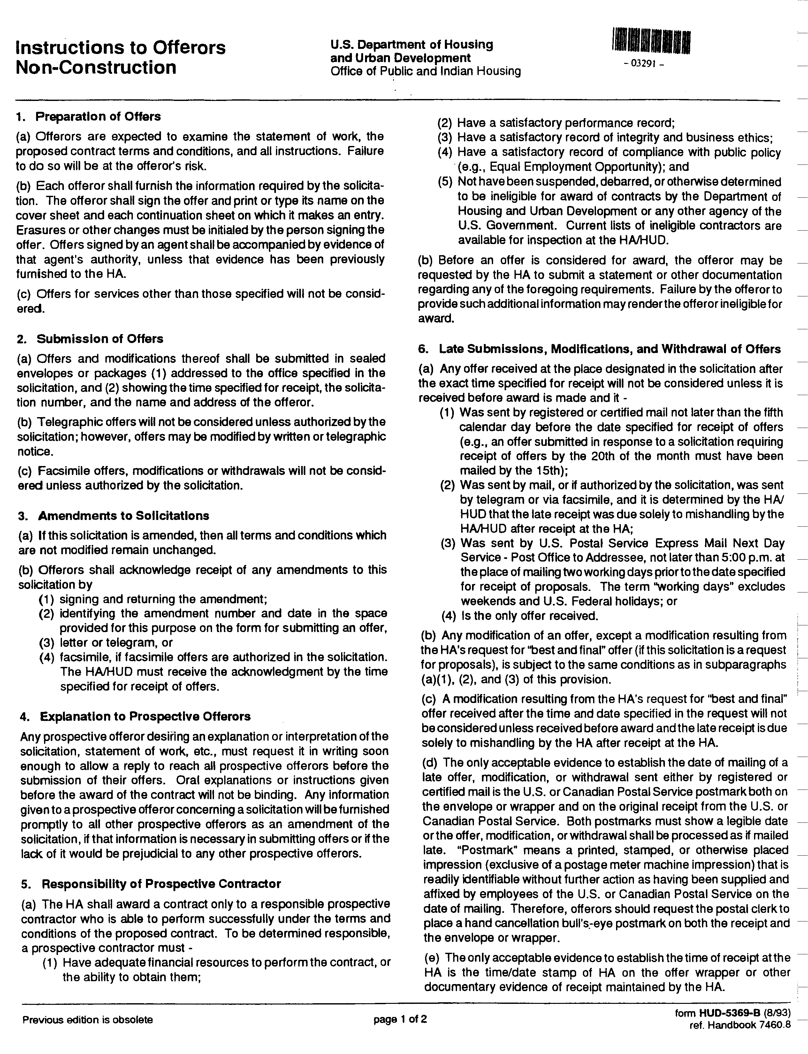

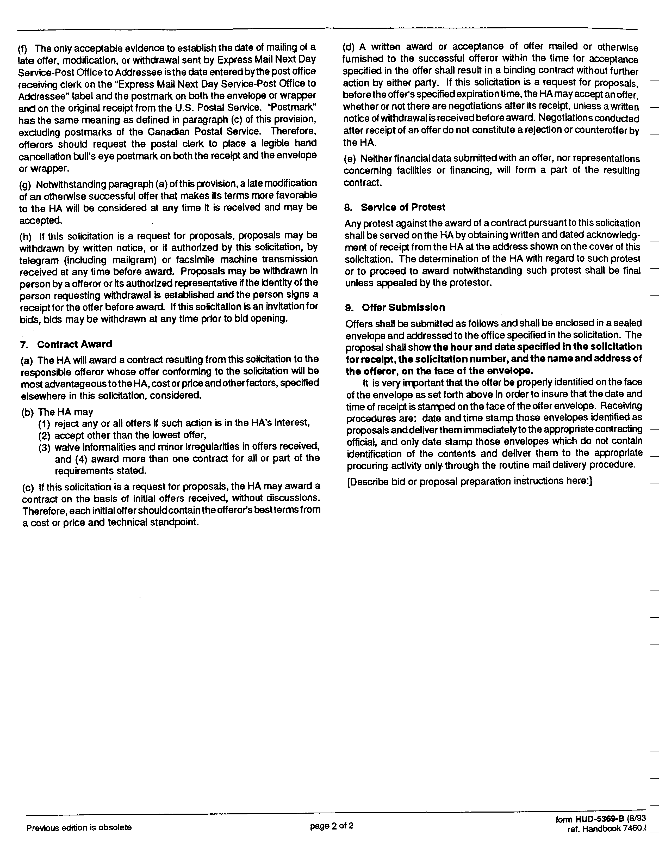

Form of
CONTRACT FOR ELEVATOR MAINTENANCE

This AGREEMENT made this 1st day of September in the year 2025 by and between

(Name of Firm)
(Address)
hereinafter called the “Contractor,” and

The Housing Authority of the City of Perth Amboy
881 Amboy Avenue, P.O. Box 390, Perth Amboy, New Jersey 08862

hereinafter Called the “Authority.”

WITNESSETH that the Contractor and the Authority for the consideration stated herein mutually agree as follows:

Article 1. Statement of Work. The Contractor shall furnish all labor materials, tools and equipment and shall perform and complete all work required in the Request for Proposals (RFP) for Elevator Maintenance and Repair Services at Richard F. Stack and Wesley T. Hansen Apartments in Perth Amboy, NJ which is incorporated by reference and made a part hereof.

Article 2. Period of Contract. This contract shall be for a period of two years commencing September 1, 2025 through August 31, 2027 and shall be renewable for two additional one-year periods or one additional two-year period at the same price stated in Article 3 at the agreement of both parties.

Article 3. Contract Price and Payments. The contract price shall be _________ dollars ($____) per year, payable in installments of _______ dollars ($_____) per month. The Authority shall make payment upon completion of all required work by the Contractor, to include the filing of all required reports and records, and the presentation of an invoice. Payment shall be due within 30 days of receipt of the invoice by the Authority.

The Authority shall pay the contractor for services not covered under the monthly maintenance agreement, or Extra Work, an hourly rate of ______________________ dollars and cents ($___. __) per hour. Materials used shall be billed at the contractor’s cost plus a mark-up of 10% (not to exceed 10%). All such extra work shall not be performed without a written work order issued to the contractor.

In the event a load test needs to be performed on any elevator, the Authority shall pay the contractor a flat rate of ___________ dollars _______ Zero cents ($_____. __) to perform a load test on either elevator at Hansen Apartments (per elevator fee) and ________ dollars and ______ cents ($_____. ___) to perform a load test on the elevator at Stack Apartments.

Travel time is included in all of the above fees. No separate travel time shall be paid by the Authority.

Article 4. Insurance. Before commencing work, the Contractor shall furnish the Authority with certificates of insurance showing the following insurance is in force and will insure all operations under the Contract;

- Workers’ Compensation, in accordance with New Jersey Workers' Compensation laws.
- Commercial General Liability with a combined single limit for bodily injury and property damage of not less than $1,000,000.00 per occurrence to protect the Contractor and the Authority against claims for bodily injury or death and damage to the property of others. This shall cover the use of all equipment, hoists, and vehicles on the site(s) not covered by Automobile Liability under (3) below. If the Contractor has a “claims-made” policy, then the following additional requirements apply: the policy must provide a “retroactive date” which must be on or before the execution date of the Contract, and the extended reporting period may not be less than five years following the completion date of the Contract.
- Automobile Liability on owned on owned and non-owned motor vehicles used on the site(s) or in connection therewith for a combined single limit for bodily injury and property damage of not less than $500,000.000 per occurrence.

All Insurance shall be carried with companies which are financially responsible and admitted to do business in the State of New Jersey. If any such insurance is due to expire during the construction period, the Contractor shall not permit the coverage to lapse and shall furnish evidence of coverage to the Authority. All certificates of insurance, as evidence of coverage, shall provide that no coverage maybe canceled or non-renewed by the insurance company until at least 30 days prior written notice has been given to the Authority.

Article 5. New Jersey Business Registration Requirements. The contractor shall provide to the Authority proof of the contractor’s business registration with the New Jersey Division of Taxation before contract award.

The contractor shall provide written notice to its subcontractors and suppliers of the responsibility to submit proof of business registration to the contractor. The requirement of proof of business registration extends down through all levels (tiers) of the project.

A business organization that fails to provide a copy of a business registration as required pursuant to section 1 of P.L. 2001, c.34 (C.52:32-44 et al.) or subsection e. or f. of section 92 of P.L. 1977, c.110 (C.5:12-92), or that provides false business registration under the requirements of either of those sections, shall be liable for a penalty of $25 for each day of violation, not to exceed $50,000 for each business registration copy not properly provided under a contract with a contracting agency.

Article 6. Contract Documents. Contract Documents shall consist of the following component parts:
- This instrument;
- General Contract Conditions - Non Construction, form HUD-5370-C II
- The RFP for Elevator Maintenance and Repair Services dated 8/19/25 including the Technical Specifications;
- Addenda (if any).

This instrument together with the document enumerated in this Article form the Contract, and they are fully a part of the Contract as if hereto attached or herein repeated. In the event that any provision in one of the component parts of the Contract conflicts with any provision of any other component part, the provision in the component part first enumerated in this Article 6 shall govern, except as otherwise specifically stated.

IN WITNESS WHEREOF, the parties hereto have caused this instrument to be executed the date and year first above written.

In the presence of
____________________________________ by : ____________________________________
Name
Title
Firm
Phone Number
In the presence of:
_____________________________________ by : ___________________________________
Douglas G. Dzema, PHM
Executive Director
Housing Authority of the City of Perth Amboy
Housing Authority of the City of Perth Amboy

Technical Specifications

for

Maintenance and Service of Three Elevators

at

Richard F. Stack Apartments
333 Rector Street

and

Wesley T. Hansen Apartments
415 Fayette Street
Perth Amboy, New Jersey

Table of Contents

Section 1: Schedule of Elevators 9
Section 2: Scope of Work 9
Section 3: Codes 9
Section 4: Periodic Maintenance 10
Section 5: Records 14
Section 6: Service Call Response 14
Section 7: Elevator Failure Caused by Water Fire, Explosion or Vandalism 14
Section 8: Schedule and Time of Work 15
Section 9: Clean Up 15
Section 10: Inspection and Testing 15
Section 11: Protection of Life and Property 16
Section 12: Authority Responsibility 16
Section 13: Access to Elevator Equipment 16

Section 1: Schedule of Elevators

Address Number of Cars Duty Cycle Travel Control

Stack Apartments 1 2,000 lbs. 1-6 Simplex Overhead
333 Rector Street @ 100 FPM Traction W/G

Hansen Apartments 2 2,500 lbs 1-11 Smart Rise Equipment
415 Fayette Street @ 200 FPM

Section 2: Scope of Work

A. The Contractor shall maintain the elevator machinery and equipment in proper and safe operating condition, on the terms and conditions hereinafter set forth. This shall include but not be limited to checking, lubricating, adjusting, repairing, replacing and such parts as are necessary or required due to ordinary wear and tear of normal operation on the automatic push-button passenger elevators listed above, and to make service calls when necessary. The services rendered by the Contractor shall be performed by trained personnel directly employed and supervised by the Contractor. Parts that need replacing that are not part of the scheduled maintenance portion of these specifications shall be billed on a time and material basis. The contractor shall submit an estimate for the necessary repairs and complete the work after such work has been pre-authorized by the Authority.

B. Where repairs are required with respect to elevators, the Contractor shall assess what is necessary to restore and maintain such elevators in a safe operating condition and provide an estimate to the Authority for approval. All equipment shall be repaired and maintained strictly in accordance with the terms of these specifications. Repairs and maintenance to parts that have been replaced or repaired shall be maintained strictly in accordance with the specifications.

C. After the award of this Contract, the Contractor shall furnish to the Authority for approval, a maintenance check list in a form suitable for monthly submission to the Authority.

D. The Contractor shall be responsible for correcting violations and complying with requirements of all applicable public agencies having jurisdiction or the Authority’s insurer, provided that such violations shall not have been placed or requirement made prior to the date of this Contract and provided that the violation or requirement does not necessitate any additions or changes to the present elevator equipment or parts, or its method of operation. Requirements of public agencies shall include, but shall not be limited to, periodic testing, witnessing of tests and properly reporting same to the Authority, including correction of defects by the Contractor.

E. The Contractor shall provide all labor, materials, transportation, equipment and necessary appurtenances to maintain, service and repair the three elevators specified herein. The Contractor shall be responsible for making scheduled and emergency service calls and for providing as nearly uninterrupted elevator service as possible during the term of this Contract. It is the Contractor's responsibility to maintain optimum efficiency and safety of the elevators by timely replacement of any parts which show excessive wear and approaching failure upon approval by the Authority.

F. In addition, the Contractor shall perform certain work on a routine basis as specifically stated herein.

G. During the normal course of preventive maintenance work, the Contractor shall be responsible for maintaining all light fixtures, including bulb replacements in the elevator machine rooms, elevator pits, top and bottom of elevators.
Section 3: Codes

A. All work done and material furnished shall be in strict accordance with all laws and with the latest rules and regulations of all State, Municipal and other agencies having jurisdiction over such matters.

B. The Contractor shall prepare and submit to such agencies, for their approval, all applications required by them, and shall obtain all necessary certificates of compliance issued by such agencies and deliver same to the Authority.
Section 4: Periodic Maintenance

A. The Contractor shall make regularly scheduled visits to perform work hereinafter described and shall also perform any additional maintenance work if part of the equipment manufacturer's standard recommendations. In the tabulation which follows, periodic checking, inspection and other responsibilities of the Contractor are set forth.

NOTE: The terms "check" or "inspect" in this list both mean also clean, clear, repair, replace, adjust, lubricate or replenish lubricant if necessary.

Time Interval Item Covered Contractor’s Work

Semi-monthly Motor Room Sweep and dust machine room.
Blow out, dust or wipe motor windings, governor jaws, sheaves and coils.
Wipe and dust off exposed surface of entire mechanism.

Semi-monthly Motor and Check lubrication.
Motor Generator Check brushes and holders.
Check commutators.
Check rotor and armature clearance.

Semi-monthly Brake Check shoes and springs.
Check pulley and fastenings.
Check electrical connections and operation.
Lubricate and check brake pins for proper fit.
Check application of brake and clearance.
Check and clean brake coils.
Check brake coil insulation.

Semi-monthly Hatch Door Check and lubricate tracks and rollers.
Check self-closing feature.
Check door gibs.

Semi-monthly Gear Box Check oil level.
Check for oil leaks.
Check stuffing box.
Check lubrication.
Check gear for wear.
Check thrust bearing.
Check oil temperature, consistence of lubricant and for gear cutting flakes.

Semi-monthly Sheave (Drive) Check for groove wear.
Check alignment.
Check for bearing wear.
Check bearing lubrication.

Semi-monthly Governor Check lubrication.
Check weights and springs for freedom of movement.
Check alignment of cable on sheave.
Check switches and contacts.

Semi-monthly Control Panels Check contacts and carbons.
and Selectors Check contacts for compression and timing.
Check overload relays.
Check for loose connections.
Check for frayed leads
Check mechanical operations.

Semi-monthly Car Doors Check distance of opening between car
strike post and edge of door
(Maximum: 1½”)
Check bumpers.
Check bottom guides and alignment.
Check car door threshold sills and sill mounted safety block.
Check and lubricate tracks and rollers.
Check removable guide shoes and safety “Z” bar guide.

Semi-monthly Car Door Check motor and lubrication.
Operator Check chain and linkages for alignment and
tension .
Check stop clearance.

Semi-monthly Hall Buttons Check plate screws.
Check bottoming of buttons and operation.

Semi-monthly Car Buttons Check buttons.
Check plate screws.
Check emergency alarms.
Check stop switch.
Check key switches

Monthly Car Top Clean top of car.
Check light fixtures and bulbs.

Monthly Hoist Ropes Visual inspection for wear and broken wires.
Inspect thimble rods and springs.
Monthly Governor Ropes Visual inspection for wear and broken wires
and socket connections.
Check cable alignment.

Monthly Pits Sweep pits and remove all rubbish, trash
paper and other foreign matter.
Check light fixture and switches.
Check pit stop switches.

Monthly Alarm Bells Check car, pit and exterior alarm bells.

Semi-annually Safety Switch Check electrical and mechanical operations.

Semi-annually Hatch Switches Check rollers and arms.
Check for level stops.
Check stop switch (Final).
Check control switches and devices.
Check automatic slow-down devices and switches.

Semi-annually Interlock Switch Check rollers, electrical operation and
and Locks latches.
Clean and lubricate.

Semi-annually Car and Check adjustment and wear.
Counterweight Check for tension.
Roller Guides Check for flats.
Check for springs.

Semi-annually Main Machine Gauge sheave groove for wear.

Semi-annually Governor Control Clean
Panel Check and tighten all terminal
connections.

Semi-annually Hoist Rope Check tension and equalizer.

Semi-annually Traveling Cable Check worn spots, tape and shellac.
Check fastening at junction box.

Semi-annually Pits. Check buffers and counterweight clearance.
Check stop switch.
Check buffer oil level.
Check light fixture and switches.

Semi-annually Car Safety Check for free operation and lubricate.
Check safety tiller rope.
Check safety plank switch.

Semi-annually Car Tighten brace rods, nuts, bolts, and screws,
car top, crosshead, platform and steady plates.
Check panel reinforcement for proper stiffness.
Check mirror and alarm bells.

Semi-annually Motor and Check brushes, brush holders and
Motor Generator commutators.
Check rotor and armature clearances

Semi-annually Motor Room Check fuses, ratings.
Check knife switch and fuse clips.

Annually Brake Clean brake cores and sleeves and lubricate
as recommended by manufacturer.
Clean brake coils.
Check brake coil insulation

Annually Control Board Check resistance tubes.
Check transformers.
Check rectifiers.
Tighten all terminal lugs.
Check Overloads

Annually Limit Switches Check car and counterweight for run-by
(Final) clearance.
Check fastenings to rails.
Check contacts (they must open before buffers are fully compressed). The above check shall also be made whenever hoist cables are renewed, or shortened.
When final limits are moved, they shall be through-bolted to rails

Annually Interlocks Inspect all internal parts.
Check door interlock keepers.

Annually Iron Work Check all shaft iron work with regard to rust
and paint.
Inspect hatch side of doors and bucks.

Annually Rails Remove fuzz and clean rails.
Check bracket bolts.
Check beams.
Check vanes and brackets.

Annually Main Machine Drain, wash and refill all motor sleeves,
bearings and gear cases.
Check gears for clearances and wear.

Section 5: Records

A. The Contractor shall forward monthly to the Authority copies of each of the following records:

- Records of service calls itemizing the nature of defect, identification by manufacturer and part number of repair parts used, time arrived, time completed, date of repair, and other pertinent information.

- The completed maintenance check list which is supplied by the Authority. This list shall also include a written report detailing equipment, operation and maintenance deficiencies (if any) which are the Authority's responsibility and the recommendations to correct same. The check list shall certify that the periodic maintenance services were performed.

B. The service person shall log in as directed by the Authority on each visit under the terms of this Contract and supply the Authority Building Manager with a copy of the completed work ticket, and notify the Authority that the car is back in service by no later than 9:00 a.m. the following day.

C. On all calls after hours, on weekends and legal holidays, the Contractor shall leave a copy of the work ticket at the Authority Building Manager’ office.

Section 6: Service Call Response

A. All service and repairs in connection with this Contract shall be performed during regular working hours of regular working days, except as specified below. If at anytime the equipment breaks down or if any emergency occurs, the Contractor shall upon receipt of such notification respond within three hours to make repairs as hereinafter specified. All other elevator outages reported to the Contractor by 9:00 a.m. shall be restored to service during regular working hours of regular working days.

B. The schedule shall be adhered to on every day of the week, at no extra charge except as specified in Section 7 below. If the Contractor does not respond within the time limit stated above, the Authority reserves the rights to obtain the services of others and back charge the Contractor for all costs.

Section 7: Elevator Failure Caused by Water, Fire, Explosion or Vandalism

A. In the event elevators become inoperable because of water, fire, explosion, or vandalism, resulting from causes other than the Contractor's failure to properly service equipment, the Contractor shall replace or repair the damaged equipment, and shall be compensated for this as Extra Work. For all material used for this Extra Work the Contractor shall be paid the actual cost of the material based on a certified paid bill from the manufacturer, plus 10% (or other amount agreed upon by the Authority and the Contractor) of said cost for overhead, profit and all other cost.

B. On each order for Extra Work, as indicated above, all time shall be billed based on the hourly rates agreed upon between the Authority and the Contractor. Standard hours shall be billed for normal working hours of Monday through Friday, 8 AM to 5PM. Premium hours shall be billed for Monday through Friday, 5PM to 8AM, Saturdays, Sundays and legal holidays. No travel time shall be allowed.

Section 8: Schedule and Times of Work

A. A schedule of work for normal periodic maintenance shall be provided by the Contractor to the Authority during the first month of the Contract term. Any overtime necessary to maintain this schedule shall be the responsibility of the Contractor and shall not entitle him to additional compensation.

B. Contractor shall perform work so that no elevator shall be out of service between the hours of 4:30 p.m. and 8:00 a.m., unless authorization in writing is issued by the Authority otherwise.

C. Cars shall not be out of service on weekends (Saturday and Sunday) or holidays, unless authorization in writing is issued by the Authority otherwise.

D. For all non-emergency work performed pursuant to specific directions of the Authority on overtime, the Contractor shall be paid the premium agreed upon between the Authority and the Contractor. Overtime shall be limited to time worked other than normal working hours for the trade in question.

Section 9: Clean Up

A. All parts or items of equipment removed shall become the property of the Contractor, and he shall remove same from the premises and legally dispose of it.

B. At the end of each work day, the work site shall be left in a broom-clean condition

Section 10: Inspection and Testing

A. All work performed under this Contract shall be subject to inspection by the Authority. If defects in material or workmanship are found, the Contractor shall be required to replace such defect at no additional cost to the Authority within thirty days of receipt of notification.

B. Contractor shall furnish all labor, materials and equipment necessary to perform and shall perform on all elevators included in this Contract the periodic inspection and safety test required by ASME A17.1-1993, Safety Code for Elevators, as amended on the date of performance.

C. The Contractor, if requested, shall accompany Perth Amboy's Elevator Sub-Code Official on the semi-annual mandated inspections. All jurisdictional tests required will be performed by the Contractor and witnessed by the Elevator Sub-Code Official.

D. All inspection and testing under this contract shall be performed by or under the direct personal supervision of persons having technical knowledge and competence in the work satisfactory to the Authority and having at least three years’ experience in elevator inspection, installation or maintenance, satisfactory to the Authority.

E. The Authority shall be notified within 24 hours in advance of any inspections or tests, in order that it may have the option to witness such inspections or tests.

F. After applications of safeties, Contractor shall file any area of rail damaged as a result of this.

G. Any damage to Authority property, which occurs during the performance of testing as required by specification, is assumed by the Authority excepting:

- Where the Contractor has not performed the required inspections in accordance with the Contract requirements.
- Where the Contractor has improperly performed the required inspections and tests.
- Where the resulting damages to property are directly due to the negligent acts or omissions of the Contractor or its employees.

H. Contractor shall make an entry in the Authority's elevator log book after each elevator test. Log books will be made available to the Contractor.

I. When tests are unsatisfactory, and when defects are found, the failures and defects shall be reported immediately to the Authority.

J. In the event an elevator fails the inspection of safety test, Contractor shall make re-inspections after corrections have been made at no added cost to the Authority.

Section 11: Protection of Life and Property

A. Contractor shall conduct his work in such manner, and take such precautions as are required, to avoid injury to any person or damage to property of the Authority and others. Any equipment furnished under this Contract, and any property of the Authority damaged by the Contractor or his employees, shall be restored to its original condition or replaced without cost of the Authority.

B. Contractor shall post a suitable sign on the lobby door of the elevator whenever any elevator is taken out of service.

Section 12: Authority Responsibility

A. The following items will be performed by the Authority and will not be the responsibility of the Contractor:

- Cleaning the inside of elevator cars, except as otherwise specified.
- Keeping the pits free of water.

Section 13: Access to Elevator Equipment

A. The Contractor shall be issued keys which will give him access to all elevator equipment. Contractor shall return all issued keys to the Authority, upon completion of the contract.

END OF TECHNICAL SPECIFICATIONS

Inspection of the Sites and Equipment

The two sites will available for inspection by prospective offerors by appointment only. Please contact Douglas Sabey at 732-794-5611 to schedule an appointment.

Submission of Proposals

Sealed written proposals must be received at the office of the Housing Authority of the City of Perth Amboy, 881 Amboy Avenue, PO Box 390, Perth Amboy, New Jersey 08862 by no later than 2:00 p.m., Tuesday, August 19, 2025. Proposals may be delivered by mail, courier or in person. Facsimile (fax) or electronic (E-mail) submissions will not be accepted.

Selection Procedure and Selection Criteria

Each proposal will be initially screened for completeness; a proposal not including all of the following will be considered incomplete and will not be considered further:

(1) Completed Proposal Form;
(2) Non-Collusive Affidavit;
(3) Qualification Questionnaire;
(4) Form HUD-5369-C, Certifications and Representations, of Offerors, Non-Construction Contract.

The following documents are not required to be submitted with the proposal, but must be submitted to the Authority prior to the award of contract:

(1) If applicable, Certification as a Minority Business Enterprise (MBE);
(2) Copy of New Jersey Public Works Contractor Registration Certification (The registration must be effective on the due date for proposals.);
(3) Copy of New Jersey Business Registration Certificate issued by the New Jersey
Department of the Treasury, Division of Revenue (The registration must be effective on the due date for proposals.);
(4) Certificate of Insurance

The Authority shall use the following criteria to evaluate proposals by point score.

(1) Evidence of the firm's ability to perform the services, as indicated by credentials and
experience. Maximum rating : 30 points
(2) References. Maximum rating: 30 points.
(3) Proposed price. Maximum rating: 35 points.
(4) Certification that that the firm is a minority-owned enterprise.
Maximum rating: 5 point.

The range of points which can be given to any proposal is 0 to l00. Firms will be ranked by their total scores with the highest score receiving the highest ranking.

The highest rank firm will be recommended for award of contract. Award of contract will be by resolution of the Board of Commissioners of the Authority.

Proposal
Proposal for: Elevator Maintenance and Repair Services
TO: Housing Authority of the City of Perth Amboy
881 Amboy Avenue, P.O. Box 390, Perth Amboy, NJ 08862
FROM:
______________________________________________________________________________
Company Name of Bidder
______________________________________________________________________________
Street Address
______________________________________________________________________________
City, State - Zip Code
______________________________________________________________________________
Contact Name / Telephone Number / Fax Number
______________________________________________________________________________
Email Address / Federal ID#

1. The undersigned, having read the specifications, including the Request for Proposals, the form of contract, contract conditions, description of the project sites and equipment, this proposal form, the form of non-collusive affidavit, the form of statement of bidder's qualifications, the Certifications and Representations of Offerers, and addenda, if any, thereto, and having investigated the local conditions affecting the cost of the work, hereby propose to furnish all labor, materials, services, equipment and related items to complete all work for elevator maintenance services at Richard F. Stack Apartments and Wesley T. Hansen Apartments in accordance therewith at the following annual fixed price:

____________________________________________________dollars and _____ cents ($_____.__) payable in twelve monthly installments of __________________________________ dollars and _____ cents ($_____.__).
Extra Work shall be billed at the following Elevator Technician rates:
Standard rate: ________________________________dollars and _____ cents ($_____.__) per hour
Premium rate: ________________________________dollars and _____ cents ($_____.__) per hour

2. Materials used shall be billed at the contractor’s cost plus a mark-up of _____% (not to exceed 10%).

3. In the event a load test needs to be performed on any elevator, the Authority shall pay the contractor a flat rate of __________________________ dollars and ____ cents ($_____.__) to perform a load test on either elevator at Hansen Apartments (per elevator fee) and ______________________________ dollars and ____ cents ($_____.__) to perform a load test on the elevator at Stack Apartments.

4. The names and address of persons interested as principals or as stockholders in this Proposal are as follows. (If the offerer is a corporation or partnership, list all persons who have 10 percent or more ownership in the corporation or partnership.)

______________________________________________________________________________
Full Name Address % of ownership
______________________________________________________________________________
Full Name Address % of Ownership
______________________________________________________________________________
Full Name Address % of ownership

The offerer shall state on the line below, whether or not he is a citizen of the United States, and in the case of a partnership, whether or not all partners are citizens of the United States.

______________________________________________________________________________

5. This Proposal is accompanied by:

(1)___ Non-Collusive Affidavit;
(2)___ Qualification Questionnaire;
(3)___ Form HUD-5369-C, Certifications and Representations, of Offerors, Non-Construction Contract;
(4)___ If applicable, Certification as a Minority Business Enterprise (MBE)
(5)___ New Jersey Public Works Contractor Registration Certification.
(6)___ New Jersey Business Registration Certificate
(7)___ Sample Certificate of Insurance

6. In submitting this proposal, it is understood that the Housing Authority of the City of Perth Amboy reserves the right to reject any and all proposals. If written notice of the acceptance of this proposal is mailed, telegraphed or delivered to the undersigned within 60 days after the receipt thereof, or at any time thereafter before this proposal is withdrawn, the undersigned agrees to execute and deliver a Contract in prescribed form within 10 days after the contract is presented to him for signature.

AFFIDAVIT
State of ______________________________
SS.
County of ____________________________

________________________________ being first duly sworn deposes and says:
(Individual’s name)
THAT he is ___________________________________________________________________,
(Owner, Officer or Partner of the firm of etc.)

the party making the foregoing proposal or bid for elevator maintenance repair services at public housing sites in Perth Amboy, New Jersey; that all statements contained in this proposal are true, accurate and complete.

________________________________________________
(Signature of Bidder)

Subscribed and sworn to before me, this ____ day of ____________________ in the year _____.

My Commission expires _________________________ _________________________________________
Date Notary Public

Non-Collusive Affidavit

AFFIDAVIT

State of ________________________

County of ______________________

_____________________________________________ being first duly sworn deposes and says:
(Individual’s Name)

THAT he is _________________________________________________________________ of
(Owner, Officer or Partner)

______________________________________________________________________________
(Firm Name)

the party making the foregoing proposal dated 8/19/25 for elevator maintenance and repair services; that such proposal is genuine and not collusive or sham; that the offerer has not colluded, conspired, connived or agreed, directly or indirectly, with any offerer or person, to put in a sham proposal or to refrain from offering a proposal, and has not in any manner, directly or indirectly, sought by agreement or collusion, or communication or conference with any person, to fix the price of affiant or of any offerer, or to fix any overhead, profit or cost element of said price, or of that of any other offerer, or to secure any advantage against the Housing Authority of the City of Perth Amboy or any person interested in the proposed contract; and that all statements in the said proposal are true.

________________________________________________
(Signature of Offerer)

Subscribed and sworn to before me, this ______ day of __________, in the year ___________

________________________________________________
Notary Public

My Commission expires __________________

Qualification Questionnaire

Proposal for: Elevator Maintenance and Repair Services

Name of Offerer: _______________________________________________________________

Address:______________________________________________________________________

______________________________________________________________________________

(a) It shall be necessary for the offerer to present evidence that he has been in business for at least three years in this field and can submit a suitable record of satisfactorily completing similar contracts.

How many years have you been or engaged in business under your present firm or trade name?
________________Years.

(b) How many years has your organization been performing the work required under this contract?

________________Years.
(c) If a corporation, answer the following:

Date of incorporation: ___________________________________________________________

State of Incorporation: ___________________________________________________________

President's Name: _______________________________________________________________

Vice President's Name(s):_________________________________________________________

(d) If a partnership, answer the following:

Date of Organization:____________________________________________________________

(e) If applicable, list New Jersey License(s) and effective dates:

______________________________________________________________________________

(f) If the contract is awarded to your firm, who will personally supervise the work?

______________________________________________________________________________

(g) Are there any liens of any character filed against your company at this time? If so, specify the nature and amount of the lien.

______________________________________________________________________________

(h) Give trade references:
______________________________________________________________________________

______________________________________________________________________________

(i) Give bank references:
______________________________________________________________________________

______________________________________________________________________________

(j) Give full information concerning all of your contracts in progress or completed within the last three years, whether private or government contracts.

OWNER/LOCATION DESCRIPTION CONTRACT AMOUNT

______________________________________________________________________________

______________________________________________________________________________

______________________________________________________________________________

______________________________________________________________________________

State of ________________________

County of ______________________

_____________________________________________ being first duly sworn deposes and says:
(Individual’s Name)

THAT he is _________________________________________________________________ of
Owner, Officer or Partner)

_____________________________________________________________________________ (Firm Name)
and that he hereby authorizes and requests any person, firm or corporation to furnish any information requested by the Housing Authority of the City of Perth Amboy in verification of the recitals comprising this Statement of Qualifications; and that all answers to the foregoing questions and all statements therein contained are true and correct.
________________________________________________
(Signature of Offerer)

Subscribed and sworn to before me, this ______ day of _________, in the year ___________
My Commission expires _________________________ _________________________________________
Date Notary Public

