Housing Authority of the City of Perth Amboy

881 AMBOY AVENUE, P.O. BOX 390, PERTH AMBOY, NJ 08862
TELEPHONE: (732) 826-3110
FAX: (732) 826-3111

EDNA DOROTHY CARTY-DANIEL, Chairperson DOUGLAS G. DZEMA, P.H.M.
FERNANDO A. GONZALEZ, Vice-Chairperson Executive Director
DIANE CRAWFORD
MIGUEL A. AROCHO
GREGORY PABON EDWARD TESTINO
DAVID BENYOLA Counsel
WILFREDO SOTO

REQUEST FOR PROPOSALS
for
LEAD-BASED PAINT ABATEMENT SERVICES
in
WILLIAM A. DUNLAP HOMES
PERTH AMBOY, NEW JERSEY

Proposals due by Thursday, September 18, 2025 at 2:00pm

CONTENTS

Introduction………………………………………………………………………………… 3

Notice - Request for Proposals …………………………………………..………………….. 3

Form of Contract……………………………………………………………………………… 4-6

Specification for Lead-Based Paint Abatement in William A. Dunlap Homes……………. . 7-16

Floor Plan Sketches, Unit Types “A” to “”H” ………………………………...………….. 17-24

Required Proposal Documents:

Proposal Form ………………………..…………………………………....………….…….. 25-26

Non-Collusive Affidavit …………....……..……….………………………………………… 27

Qualification Questionnaire ………...………………………………………..………………. 28-29

Perth Amboy Housing Authority
Request for Proposals
Lead Based Paint Abatement Services

Introduction - The Housing Authority of the City of Perth Amboy (Authority) has a need for “as-needed” lead based paint abatement services in William A. Dunlap Homes located in Perth Amboy, NJ. The work shall include the removal lead based paint in vacated apartments as needed.

The contract shall be for a two-year term, renewable at the agreement of both parties for two additional one-year periods or one additional two-year period at the same terms and rates.

The estimated value of this contract shall be approximately $12,000.00 per year. The Authority in no way guarantees this amount or any minimum or maximum value of the contract.

Notice – Request for Proposals

The Housing Authority of the City of Perth Amboy (Authority) will receive proposals for lead-based paint abatement services in William A, Dunlap Homes, Perth Amboy, New Jersey. This Request for Proposals is for a two-year service contract, renewable at the agreement of both parties for two additional one-year periods or one two-year period.

Proposals will be received until 2:00 p.m. Thursday, September 18, 2025, prevailing time, at the offices of the Authority, 881 Amboy Avenue, PO Box 390, Perth Amboy, NJ 08861.

All requirements for the work and for submitting an offer are described in the written Request for Proposals (RFP). The RFP may be obtained at the Authority office at the above address, or at the Authority’s website: www.PerthAmboyHA.org.

The Authority invites the participation of Minority-Owned Business Enterprises in this solicitation.

The Authority reserves the right to reject any or all offers or to waive any informalities in this solicitation.

Form of Contract (DO NOT SUBMIT)

For Lead-Based Paint Abatement Services

This AGREEMENT made this 1st day of October in the year 2025 by and between

(Name of Contractor)
(Address)

hereinafter called the "Contractor,” and the

Dunlap RAD LLC
881 Amboy Avenue, P.O. Box 390, Perth Amboy, New Jersey 08862

hereinafter called the "Authority".

WITNESSETH that the Contractor and the Authority for the consideration stated herein mutually agree as follows:

Article 1. Statement of Services. The Contractor shall furnish all labor materials, tools and equipment and shall perform and complete all work required for lead-based paint abatement in vacant apartments in William A. Dunlap Homes, Perth Amboy, New Jersey.

Article 2. Term of Contract. This contract shall extend for a period of two years, October 1, 2025 through September 30, 2027. The contract shall be renewable for two additional one-year periods or one additional two-year period at the agreement of both parties and at the same rates stated in Article 5 below.

Article 3. Performance of Work. All work shall be performed in strict accordance with the “Specification for Lead-Based Paint Abatement in William A. Dunlap Homes,” hereunto attached and fully made a part of this contract. The Authority shall have the sole right and discretion to order work under his contract The Authority reserves the right to award work of a similar nature, through other procurement methods, to other contractors.

Work shall be performed by the Contractor on an as-needed basis. The Authority makes no representation as to the amount of work that may be required during the contract period.

The Authority shall notify the Contractor of all work to be performed by means of a written “Notice to Proceed” work order. The Notice to Proceed shall specify the building components to be abated in each apartment. The Contractor shall complete each work order within thirty (30) calendar days of the date of the Notice to Proceed. If the Contractor fails to complete the work within the number of days specified, the Contractor shall be liable to the Authority as liquidated damages the sum of two hundred dollars ($250.00) for each day of delay.

Work shall be performed during the Authority’s standard business hours: 8:30 a.m. to 4:30 p.m., Monday to Friday exclusive of holidays.

Article 4. Work Requirements and Contractor’s Responsibility. The Contractor shall be responsible for furnishing all materials, equipment, labor and transportation necessary to perform the work.

All work shall be performed in accordance with federal, State, County and local statutes, regulations and codes presently established or as may be established during the term of this contract. If the Contractor performs any work contrary to any federal, State, County or local statute, ordinance, regulation or code, he shall assume full responsibility and shall bear any and all costs attributable thereto

The Contractor shall be responsible to apply for and secure any and all permits and to provide all notifications required by governing authorities to perform the work.

The Contractor shall be responsible for all materials delivered and work performed until completion and acceptance of each work order.

The Contractor shall not sub-contract any work under this contract without express prior written approval of the Authority.

The Contractor shall at all times keep the work area orderly and free from accumulations of waste materials. After completing each work order, the Contractor shall remove all equipment materials and tools that are not the property of the Authority and leave the work area in a neat, clean and orderly condition.

The Contractor shall be responsible for all damages to persons or property that occur as a result of the Contractor’s fault or negligence, and shall take all necessary health and safety precautions to protect the work, the workers, the public, and the property of others. The Contractor shall hold and save the Authority, its officers and agents, free and harmless from liability of any nature occasioned by the Contractor’s performance.

Article 5. Rates and Payments. The Authority shall pay the Contractor for lead-based paint abatement work completed on various apartment building components in accordance with the Contractor’s Price Proposal, hereunto attached and fully made a part of this contract.

The Authority shall make payments upon the completion of all work and final clearance and the presentation of an invoice by the Contractor. “Completion of all work and final clearance” is understood to include completion of the lead-based paint abatement work, completion of visual clearance, completion of clearance dust sampling, completion of laboratory analysis of dust samples and receipt of the laboratory report, and closing of the permit for the work. Payment shall be due within 30 days of receipt of the invoice by the Authority.

Article 6. Insurance. Before performing any work, the Contractor shall furnish the Authority with certificates of insurance showing the following insurance is in force and will insure all operations under the Contract:

- Workers’ Compensation, in accordance with New Jersey Workers' Compensation laws.
- Commercial General Liability with a combined single limit for bodily injury and property damage of not less than $2,000,000.00 per occurrence to protect the Contractor and the Authority against claims for bodily injury or death and damage to the property of others. This shall cover the use of all equipment, hoists, and vehicles on the site(s) not covered by Automobile Liability under (3) below. If the Contractor has a “claims-made” policy, then the following additional requirements apply: the policy must provide a “retroactive date” which must be on or before the execution date of the Contract, and the extended reporting period may not be less than five years following the completion date of the Contract.
- Automobile Liability on owned on owned and non-owned motor vehicles used on the site(s) or in connection therewith for a combined single limit for bodily injury and property damage of not less than $500,000.00 per occurrence.

All Insurance shall be carried with companies which are financially responsible and admitted to do business in the State of New Jersey. If any such insurance is due to expire during the construction period, the Contractor shall not permit the coverage to lapse and shall furnish evidence of coverage to the Authority. All certificates of insurance, as evidence of coverage, shall provide that no coverage maybe canceled or non-renewed by the insurance company until at least 30 days prior written notice has been given to the Authority.

Article 7. New Jersey Business Registration Requirements. The contractor shall provide to the Authority proof of the contractor’s business registration with the New Jersey Division of Taxation before contract award and shall provide written notice to its subcontractors and suppliers of the responsibility to submit proof of business registration to the contractor.

A business organization that fails to provide a copy of a business registration as required pursuant to section 1 of P.L. 2001, c.34 (C.52:32-44 et al.) or subsection e. or f. of section 92 of P.L. 1977, c.110 (C.5:12-92), or that provides false business registration under the requirements of either of those sections, shall be liable for a penalty of $25 for each day of violation, not to exceed $50,000 for each business registration copy not properly provided under a contract with a contracting agency.

Article 8. Contract Documents. Contract Documents shall consist of the following component parts:

- This instrument;
- Specification for Lead –Based Paint Abatement in William A. Dunlap Homes;
- General Contract Conditions - Non Construction, form HUD-5370-C-II; and
- Addenda (if any).

This instrument together with the document enumerated in this Article form the Contract, and they are fully a part of the Contract as if hereto attached or herein repeated. In the event that any provision in one of the component parts of the Contract conflicts with any provision of any other component part, the provision in the component part first enumerated in this Article 8 shall govern, except as otherwise specifically stated.

IN WITNESS WHEREOF, the parties hereto have caused this instrument to be executed the date and year first above written.

In the presence of:

____________________________________ by_______________________________________
(Name)
(Title)
(Company Name)
(Phone Number)
In the presence of:

_____________________________________ by______________________________________
Douglas G. Dzema, PHM
Executive Director
Housing Authority of the
City of Perth Amboy

Specification for Lead-Based Paint Abatement
in
William A. Dunlap Homes

1.0 GENERAL REQUIREMENTS

1.1 Scope of Work

The Contractor shall provide all tools, labor and materials needed to perform abatement of lead-based paint (LBP) on various surfaces and building elements in apartments in William A. Dunlap Homes, Perth Amboy, New Jersey. Abatement work will be performed in vacant apartments only at unit turnover.

  - Notice to Proceed

The Authority shall issue the Contractor a written Notice to Proceed for each apartment to be abated describing each surface or building element to be abated.

  - Permits and Notifications

The Contractor shall be responsible to secure all permits required to perform the abatement work and to provide all notifications where required by State or local law or regulation.

1.4 Performance Period for Abatement Work

The Contractor shall complete all abatement work for each apartment no later than thirty (30) days after the date of the Notice to Proceed. If a delay in processing a permit application or other cause beyond the Contractor’s control would prevent the completion of the work within the specified time, the Contractor shall promptly notify the Authority of the cause of the delay.

2.0 WORK SITE MANAGEMENT

2.1 Posting and Filing of Regulations

Maintain two (2) copies of applicable federal, state and local regulations. Keep one copy of each at the job site where workers will have ready, easy and daily access to the text. Keep one copy of each on file in Contractor's office.
2.2. Personnel

A. Administrative and Supervisory Personnel shall consist of a qualified general superintendent and appropriate number of qualified or competent foremen. The Contractor's "competent person," as defined by the federal Occupational Health and Safety Administration (OSHA), must meet all OSHA requirements.

B. Administrative personnel shall work full time for the Contractor and be dedicated to this project. These employees are the Contractor's representatives responsible for compliance with these specifications. They must meet the minimum qualifications criteria described in Paragraph 4 below.

C. Non-Supervisory Personnel: An adequate number of qualified personnel shall be able to meet the schedule requirements of the project. Laborers employed for abatement throughout the project shall meet the minimum qualifications criteria described in Paragraph 4 below.

D. Minimum Qualifications: The Abatement Contractor and assigned personnel for this contract shall meet the following minimum requirements:

1. The Lead Abatement Contractor: Is certified by the New Jersey Department of Community Affairs as a Lead Abatement Contractor; Has an established Lead-Based Paint (LBP) abatement business for five (5) years; Has conducted within the last three (3) years five (5) LBP abatement projects; Has not defaulted on any project within the last five (5) years; Has not been cited or has not been a defending party of any legal action for violation of LBP regulations; Carries liability insurance for LBP abatement work; Has an adequate number of qualified personnel available to perform the work under this contract; Has an established written standard operating procedure for training, medical surveillance, entry and exit procedures, respiratory protection, safety, emergency and monitoring; Has available equipment, materials and supplies in adequate quantity, capacity and number to perform the work under this contract.

2.. Supervisor: Is certified by the New Jersey Department of Health as a LBP Abatement Supervisor; Has completed a Lead Abatement Supervisor's course at an EPA and State of New Jersey approved Training Center or equivalent certificate course in LBP abatement procedures; Has at least three (3) years abatement experience of which at least one (1) years as a supervisor; Has worked as supervisor in at least three (3) projects.; have completed two (2) courses of specialized training in LBP abatement construction and regulations.. Have medical records and other OSHA requirements.

3. Workers: Are certified by the New Jersey Department of Health as LBP Abatement Workers; Have completed an EPA and State of New Jersey approved LBP handlers/workers training course; Have specialized training in abatement procedures, OSHA and EPA regulations, the standard operating procedure of the company, LBP hazards and respiratory protection; Have medical records and other OSHA requirements.

2.3 Authorized Entry

Provide security at the entrance of a containment area to ensure that only properly trained and outfitted workers will be allowed to enter. Entrance will be allowed also to any authorized Authority representatives and inspectors from regulatory agencies if properly certified and fitted with protective clothing and respirators

3.0 STOP WORK ORDER

If the Authority’s Contracting Officer or his designated agent presents a written stop work order, the Contractor shall immediately stop all LBP removal and initiate dust reduction activities. Do not resume LBP removal until authorized in writing by the Authority. A stop work order will be issued at any time the Authority determines abatement conditions are not within specification's requirements. Stoppage will continue until conditions have been corrected. Standby time and cost required for corrective action is at Contractor's expense. The occurrence of the following events shall be reported in writing to the Authority and shall require the Contractor to automatically stop LBP removal and initiate dust reduction activities:

A. Airborne lead level outside containment area (1.5 ug/m³ or greater, EPA/OSHA recommended standard).
B. Break in Containment Barriers.
C. Loss of negative air pressure (at or below 0.02 inches of water).
D. Serious injury within the containment area.
E. Fire and Safety Emergency due to abatement.
F. Respiratory System failure.
G. Power failure due to abatement.

4.0 CODES AND REGULATIONS

4.1 General Applicability of Codes, Regulations and Standards

Except to the extent that more explicit or more stringent requirements are written directly into the contract documents, all applicable codes, regulations, and standards have the same force and effect (and are made a part of the contract documents by reference) as if copied directly into the contract documents, or as if published copies are bound herewith.

4.2. Contractor Responsibility

A. The Abatement Contractor shall assume full responsibility and liability for the compliance with all applicable Federal, State and local regulations pertaining to work practices, hauling and disposal of LBP waste, and protection of workers, visitors to the site, and persons occupying areas adjacent to the site. Contractor is responsible for providing medical examinations and maintaining medical records of personnel as required by the applicable Federal, State and local regulations. Contractor shall hold the Authority harmless for failure to comply with any applicable work, hauling, disposal, safety, health or other on the part of himself, his employees or his subcontractors. Contractor incurs all costs including sampling/analytical costs for sampling to comply with OSHA regulations. Abatement Contractor shall determine the applicability of any process patents he/she may be employing and be responsible for paying any fees, royalties or licenses that may be required for the use of patented processes.

B. Should the Authority permit the Contractor to use any of its equipment, tools, or facilities, such will be gratuitous, and the Contractor shall release the Authority from indemnity and save harmless the Authority from and against any claims for personal injuries; including death, arising out of the use of such equipment, tools or facilities, whether or not based upon the completion thereof or any alleged negligence of the Authority in permitting the use thereof.

C. Trade Union Jurisdictions: It is a procedural requirement that the Contractor maintain, and require any subcontractors to maintain, complete current information on jurisdictional matters, regulation actions and pending actions, as applicable to the work. Discuss new developments at appropriate project meetings at the earliest feasible dates, and record information of relevance along with the action agreed upon. The manner in which contract documents have been organized and subdivided is not intended to be an indication of jurisdictional or trade union agreements. Assign and subcontract the work, and employ tradesmen and laborers, in a manner that will not unduly risk jurisdictional disputes of a kind which could result in conflicts, delays, claims and losses in the performance of the work.

D. The Contractor shall be responsible for all fines, citations, injunctions or other actions from any governmental or regulatory agency resulting from actions on the part of himself, his employees, or his subcontractors.

E. The Contractor shall take full responsibility for failure of materials, devices, equipment, Systems and finishes installed, erected or applied in accordance with the requirements of this article and shall remove, replace, repair or correct any such failures or deficiencies promptly upon discovery/notification by her/himself or the Authority.

F. The Contractor shall provide for, maintain in operation all existing services intended to remain after the alterations, and restore all such services if damaged to normal standard operating condition unless otherwise required by specification requirements. Maintenance of warning signs, barriers, lights, and other precautions shall be the responsibility of the Contractor directly involved with the particular work underway.

G. The Authority shall provide to the Contractor information concerning the shut-down and protection requirements of certain equipment/systems throughout the work site.

4.3. Federal Requirements

Federal requirements which govern worker health and safety, LBP abatement work or hauling and disposal of lead waste include but are not limited to the following:

A U.S. Department of Labor, Occupational Safety and Health Administration, (OSHA):
- 29 Code of Federal Regulation (CFR), Part 1910, Section 2, Access to Employee Exposure and Medical Records
- 29 CFR, Part 1910, Section 1200, Hazard Communication
- 29 CFR, Part 1910, Section 145, Specifications for Accident Prevention Signs and Tags
- 29 CFR, Part 1910, Section 1025, Lead
- 29 CFR, Part 1926, General Health and Safety Provisions for Construction Work

B. U.S. Environmental Protection Agency (USEPA):
- Resource Conservation and Recovery Act (RCRA) of 1976;
- Hazardous and Solid Waste Amendments (HSWA) of 1980 & 1984.
- 40 CFR , Part 745, Subpart P, Management and Disposal of Lead-Based Paint Debris

C. U.S. Department of Housing and Urban Development, (HUD):
- Guidelines for the Evaluation and Control of Lead-Based Paint Hazards in Housing
- 24 CFR, Part 35 et al., Requirements for Notification, Evaluation and Reduction of Lead-Based Paint Hazards in Federally Owned Residential Property and Property Receiving Federal Assistance

D. National Institute for Occupational Safety and Health (NIOSH)
- Publication N1OSH 87-108
- NIOSH - Respirator Decision Log.

4.4. State Requirements

State requirements which govern LBP abatement work or hauling and disposal of lead waste materials include but are not limited to the following:
- New Jersey Administrative Code (NJAC) 5:17, New Jersey Department of Community Affairs (NJDCA)
- NJAC 5:12-8, NJDCA
- NJAC 8:60, New Jersey Department of Health (NJDOH)
- NJAC 12:120, New Jersey Department of Labor (NJDOL)
- New Jersey Statutes Annotated (NJSA)12:1D9, 12:1 et seq., New Jersey Department of Environmental Protection (NJDEP)
- NJAC 7:26, NJDEP
- NJSA 13:IE, NJDEP
4.5 Local Requirements

Abide by all local requirements if these requirements are more stringent than federal or State which govern LBP abatement work or hauling and disposal of lead waste materials.

4.6 Standards

A. Standards which govern LBP abatement work or hauling and disposal of lead waste materials include but are not limited to the following:
- American National Standards Institute (ANSI) Publication Z92-79, Fundamentals Governing the Design and Operation of Local Exhaust Systems
- ANSI Publication V82, Practices for Respiratory Protection

B. OSHA Lead dust standard:
- “Action Level”: 30 ug/m³:
- Permissible Exposure Limit: 50 ug/m³ as a 8-hour time weighted average.

C. EPA Lead Dust Standard: 1.5 ug/m³ ambient air /ASHRAE indoor air guideline

D. HUD Lead Dust Clearance Levels
- Floors: 10 ug/ft²
- Window Sills: 100 ug/ ft²
- Window Troughs: 400 ug/ ft²

4.7 Notices

A. A copy of notification shall be sent, with an appropriate cover letter to the New Jersey Department of Health, New Jersey Department of Labor, New Jersey Department of Community Affairs and New Jersey Department of Environmental Protection.

B. To ensure a timely commencement of work, the Contractor shall send the regulatory notifications immediately after receipt of the Notice to Proceed for abatement of any dwelling unit. In the event the Contractor has difficulty in sending notifications or obtaining permits, the Contractor shall immediately notify the Authority.

5.0 RESPIRATORY PROTECTION

5.1 General

Provide respiratory protection in accordance with these specifications, the OSHA regulations 29 CFR 1926.62, EPA regulations 40 CFR 763.120, 121, ANSI standards Z882-1980, the NIOSH standards and the following state and local requirements. In case of conflict, the most stringent requirements are applicable for this project

5.2 Respirators for Abatement Operations

Where a worker is or could reasonably be expected to be exposed during abatement operations to airborne lead above 30 ug/m³, or where LBP debris is visible respiratory protection is required. Where respirators are used, the Contractor shall select and provide, at no cost to the employee, the appropriate respirator and shall ensure that the employee uses the respirator provided. The Contractor shall select respirators from among those approved as being acceptable for protection by the National Institute of Occupational Safety and Health (NIOSH) under the provision of 30 CFR Part 11.
6.0 WORKER PROTECTION

  - Compliance Plan

The Contractor shall prepare a written Compliance Plan that specifically describes how OSHA standards and the requirements of this specification will be implemented in carrying out the work under the contract. A copy of the plan will be submitted to the Authority.
  - Medical Surveillance

Provide medical examinations for all workers and any other employees entering the Work Area per OSHA 29 CFR 1926.62 regardless of exposure levels. In addition, the Contractor's physician shall perform an evaluation of each individual's ability to work in heat stress environments. For lead workers, additional medical examinations are involved, such as, Pre-placement Medical Examination, Annually Periodic Medical Examination Blood lead level shall be monitored during these medical examinations. Analysis of blood samples must be conducted by a laboratory approved by OSHA.

  - Protective Clothing

A Provide boots, hard hats, safety goggles and gloves as needed for all workers and sub-contractors. Equipment shall meet OSHA requirements for personal protection Provide all persons entering the Work Area with disposable fall body coveralls, disposable head covers and eighteen (18)-inch boot type covers. Ensure that disposable clothes will not be compromised by employees. Provide disposable plastic or rubber gloves to protect hands. Cloth gloves may be worn inside the disposable gloves but shall not be used alone. Use tape to secure sleeves at the wrists and to secure foot coverings at the ankles.

B. Respirators, disposable coveralls, head coven and footwear covers shall be provided by the Contractor for the Authority’s authorized representatives who may inspect the job site.
C. The Contractor shall provide all employees and authorized visitors with any additional safety and personal protective equipment that may be required due to the nature of the work being performed. All such equipment shall meet the requirements of any applicable OSHA regulations.

  - Limitations within Work Area

Ensure that workers do not eat, drink, smoke, chew gum or tobacco, or in any way break the protection of the respiratory protection system in the Work area.

6.4 Medical Removal Protection

Medical removal is designed to give employees time to reduce blood lead levels. With good engineering, work practices, personal hygiene, and respiratory protection practices in place, very view employees should reach removal trigger levels. There are different types of removals, while employees are removed, they must be placed in jobs that will not result in additional exposure to lead. Removal from lead exposed occupations is triggered by results of employee blood testing or physicians orders. Special provisions for blood lead monitoring shall be followed when worker's blood level exceeds 40 ug/dl (see HUD guideline).

7.0 CONTAINMENT BARRIERS AND COVERINGS OF WORK AREA

7.1 General

Seal off perimeter of Work Area to completely isolate abatement areas and to contain all airborne lead dust contamination created by abatement work Cover all surfaces of the Work Area to protect them from cross contamination, to facilitate more efficient clean-up, and to protect the finishes from the LBP abatement work Should the area beyond the seal off limits become contaminated as a consequence of the work, clean those areas in accordance with procedures described in this section at no additional cost to the Authority.

7.2 Critical Barriers

Place all tools and materials necessary for the work in the area to be isolated prior to erection of barriers. Critical Barriers shall be put in place to isolate the work area. The Critical Barriers shall mean a minimum of two (2) layers of polyethylene sheeting of nominal six (6) mil thickness to separate the Work Area from other portions of the building, and the outside. Seal all doorways, windows, and other openings into the Work Area with polyethylene sheeting, taped securely in place with duct tape. Maintain seal until all work including project decontamination is completed. Seal the perimeter of all sheet plastic barriers with duct tape.

  - Warning Signs

Provide warning signs at each front and rear entrance to the dwelling unit per OSHA requirements. The warning signs shall be a minimum of 8.5" X 11" and should contain the following information:

WARNING

LEAD WORK AREA

POISON

NO SMOKING OR EATING

  - Breach of Work Area

If the enclosure barrier is breached in any manner that could allow the passage of LBP debris or airborne lead dust, then where possible, add affected area to the work area enclose it as required by this section of the specification and decontaminate it as described elsewhere in this section if contaminated area cannot be added to work area, decontamination measures shall start immediately after contamination is discovered and work will stop in work area Decontamination procedures will continue until exposure returns to background levels.

8.0 MONITORING. INSPECTION AND TESTING

Perform throughout abatement work monitoring, inspection and testing inside the Work Area in accordance with OSHA requirements. The Contractor Superintendent shall oversee the performance of the workers and shall continuously inspect and monitor conditions inside the Work Area to ensure compliance with this specification. In addition, the Contractor’s Safety Officer, who shall meet the OHSA definition of “competent person,” shall manage all systems and procedures identified in the Compliance Plan affecting the health and safety of the LBP abatement workers, and shall periodically inspect the Work Area to ensure compliance with the plan and to perform any required testing, including personal exposure monitoring and air monitoring. The safety of the Contractor’s employees and all other persons entering the Work Area is the exclusive responsibility of the Contractor.

- ACCEPTABLE METHODS OF LEAD-BASED PAINT ABATEMENT

9.1 LBP Methods Applicable to this Contract

LBP methods applicable to this contract shall be limited to: paint removal by heat gun, wet scraping and/or chemical stripping, and repainting; and permanent enclosure of LBP surfaces with gypsum board. Encapsulation of LBP surfaces will not be permitted.
  - Paint Removal Methods and Repainting

A. Paint may be removed using a razor sharp scraper and water misting to reduce lead dust levels.
B. Paint may be removed by heating with an electric-powered heat gun, not capable of producing temperatures in excess of 1,100 degrees Fahrenheit, to soften paint film and scrapping of the loosened paint from the surface. If using this method, workers shall wear respirators with protection for both organic vapors and lead dust. A fully charged ABC type fire extinguisher, 20-pound minimum, shall be available within 20 feet of the work.

C. Paint may be removed by chemical stripping agents following manufacturer’s directions not otherwise prohibited by any applicable laws, regulations or standards. Chemical stripper shall be neutralized according to manufacturer’s directions. Stripped surfaces shall be washed with a high phosphate detergent or functional equivalent to remove lead residues.

D. Visual inspection of all surfaces where paint has been removed shall be conducted by a Authority representative who shall be certified by the New Jersey Department of Health as a LBP Inspector/Risk Assessor. If so directed by the Inspector, the Contractor shall repeat paint removal procedures at no cost to the Authority until all visible traces of paint are removed. Surfaces shall not be re-painted until a written Lead Hazard Visual Clearance Form has been issued by the Inspector.

E. Clean abatement area using procedures described below for final cleaning prior to re-painting stripped surfaces.

F. Scrapped or stripped surfaces shall be re-painted with a primer and two coats of finish paint.

9.4 Prohibited Methods of Paint Removal

The following methods of paint removal are prohibited: dry scrapping, grinding, sanding, sand or abrasive blasting, hydroblasting, open flame torching, use of any heat gun producing temperatures exceeding 1,100 degrees F., use of any chemical stripper containing methylene chloride or any other substance which is a known or suspected human carcinogen, as specified in the USEPA Guidelines for Carcinogen Risk Assessment, or its successor regulation, document or guideline.
  - LBP Abatement by Permanent Enclosure

A. Prepare the surface for enclosure. All loose paint shall be removed by wet scrapping as described above. Repair any structurally unsound substrates. Remove any protruding nails, screws or other obstructions.

B. The surfaces to be enclosed shall be marked by stamping approximately every two (2) feet horizontally and vertically in permanent ink with the warning,

“DANGER: LEAD-BASED PAINT.”

C. Install Type X, fire-rated gypsum board 5/8” in thickness in all areas except bathrooms. In bathrooms install 5/8” water resistant gypsum board. Acceptable manufacturers include: United States Gypsum, Georgia-Pacific.

D. Adhere gypsum board to plaster or concrete substrate using PL 200 or other suitable construction adhesive. Secure boards to plaster substrates using coarse thread drywall screws, 1-5/8 in length. Secure boards to concrete substrates using Hilti or other suitable concrete anchoring fasteners.

E. Use extension rings to bring electrical devices flush with the new gypsum board surface.

F. Whenever the gypsum board meets door or window frames, baseboard, etc., use “J” channels to achieve a neat, workmanlike finish. Apply metal corner beads on all outside corners of gypsum boards.

G. Seal the gypsum boards at floor, ceiling, all other horizontal and vertical perimeter edges, and all wall penetrations with a continuous bead of fire-resistant caulking or sealant that has a warranty of at least 20 years.

H. Tape and finish gypsum board joints using paper reinforcing tape and mixed joint compound. Spackle all fastener heads and dimples with compound. Apply second and finish coats of compound and sand as needed to achieve a neat, smooth workmanlike finish.

  - Safety Standards

A. The LBP Contractor and the LBP Abatement Supervisor shall ensure that all abatement work is performed in compliance with all applicable federal State and local laws, regulations, guidelines and safety standards and shall be jointly and severally liable for any violations.

B. The Contractor shall ensure that the Work Area is arranged equipped and supervised in a manner that will minimize the possibility of lead-contaminants or other hazardous materials escaping from the abatement area.
C. All chemical strippers, solvents or other flammable or hazardous materials shall be delivered to the Work Area and maintained in their original containers bearing the manufacturer’s labels and instructions. Material Safety Data Sheets for all hazardous materials shall be maintained on-site and made available for review upon request.

D. Upon finishing work each day, all rags, cloths or other supplies used in conjunction with chemical strippers, flammable or hazardous materials, or materials contaminated with lead dust or paint, shall be stored in appropriate closed safety cans or containers, or removed from the premises.

- CLEANING, CLEARANCE TESTING AND WASTE DISPOSAL

10.1 Daily Cleaning

A. At the completion of work each day, the Work Area shall be thoroughly vacuumed with a HEPA vacuum capable of filtering all particles of 3 microns or greater at 99.97% efficiency or greater, or wet-mopped, to remove all visible dust and debris. Waste shall be placed in a plastic bag of 6-mil thickness or double bags of 4-mil thickness, sealed and labeled and disposed of properly.

B. At the completion of work each day, the entrance to the work area and the apartment shall be inspected to ensure that no dust or debris has escaped the containment. If any such dust or debris is observed, this shall be HEPA-vacuumed or wet-mopped and disposed of as described above.

  - Final Cleaning

A. Remove all plastic sheeting within the containment area. Spray or mist plastic sheeting with water and fold sheets from the ends to the middle in the following order: upper level sheets, top floor sheets, bottom floor sheets. Plastic sheeting used to isolate the containment area shall remain in place. Place folded plastic sheeting and disposable work clothing in plastic bags as described above.

B. HEPA-vacuum power tools and equipment. Wash all down all tools and equipment with rags or sponges using high phosphate detergent or equivalent to bind lead dust.

C. HEPA-vacuum abatement area, working from points farthest from the entrance towards the entryway.

D. Wet-wash the abatement area with high phosphate detergent or equivalent, working from upper surfaces to floors. String mops and mop buckets with wringer shall be used for mopping floors; sponge mops shall not be used.

E. Re-vacuum abatement area with HEPA vacuum.

F. Remove and dispose of plastic sheeting for containment area as described above. Inspect adjacent areas for evidence of dust contamination, if any is observed, clean following above procedures.

  - Alternative Cleaning Methods

Alternative cleaning methods may be proposed in writing by the Contractor and may be used with the written approval of the Authority.

  - Clearance Testing

Final clearance testing by dust wipe sampling shall be conducted by a Lead Inspector/Risk Assessor employed by the Authority. Samples shall be recorded on a Lead Hazard Control Clearance Dust Sampling Form All dust wipe samples must meet the HUD Lead Dust Clearance Levels identified in Section 4.6 of this specification. If any dust wipe sample exceeds these levels, the Contractor shall promptly repeat final cleaning of the affected area at no cost to the Authority until the HUD clearance levels are achieved.

  - Waste Disposal
A. The Contractor shall remove all hazardous and non-hazardous wastes from the Authority premises at the end of the abatement process for each apartment and shall dispose of all wastes off-site. Transportation of hazardous wastes and waste disposal shall be conducted in compliance with all federal State and local laws, regulations and requirements identified in this specification or otherwise applicable.

B. The Contractor shall maintain manifests for transportation of hazardous wastes to an EPA-approved treatment, storage and disposal facility, and any and all other documentation required by law or regulation, and shall make these documents available to the Authority upon request.
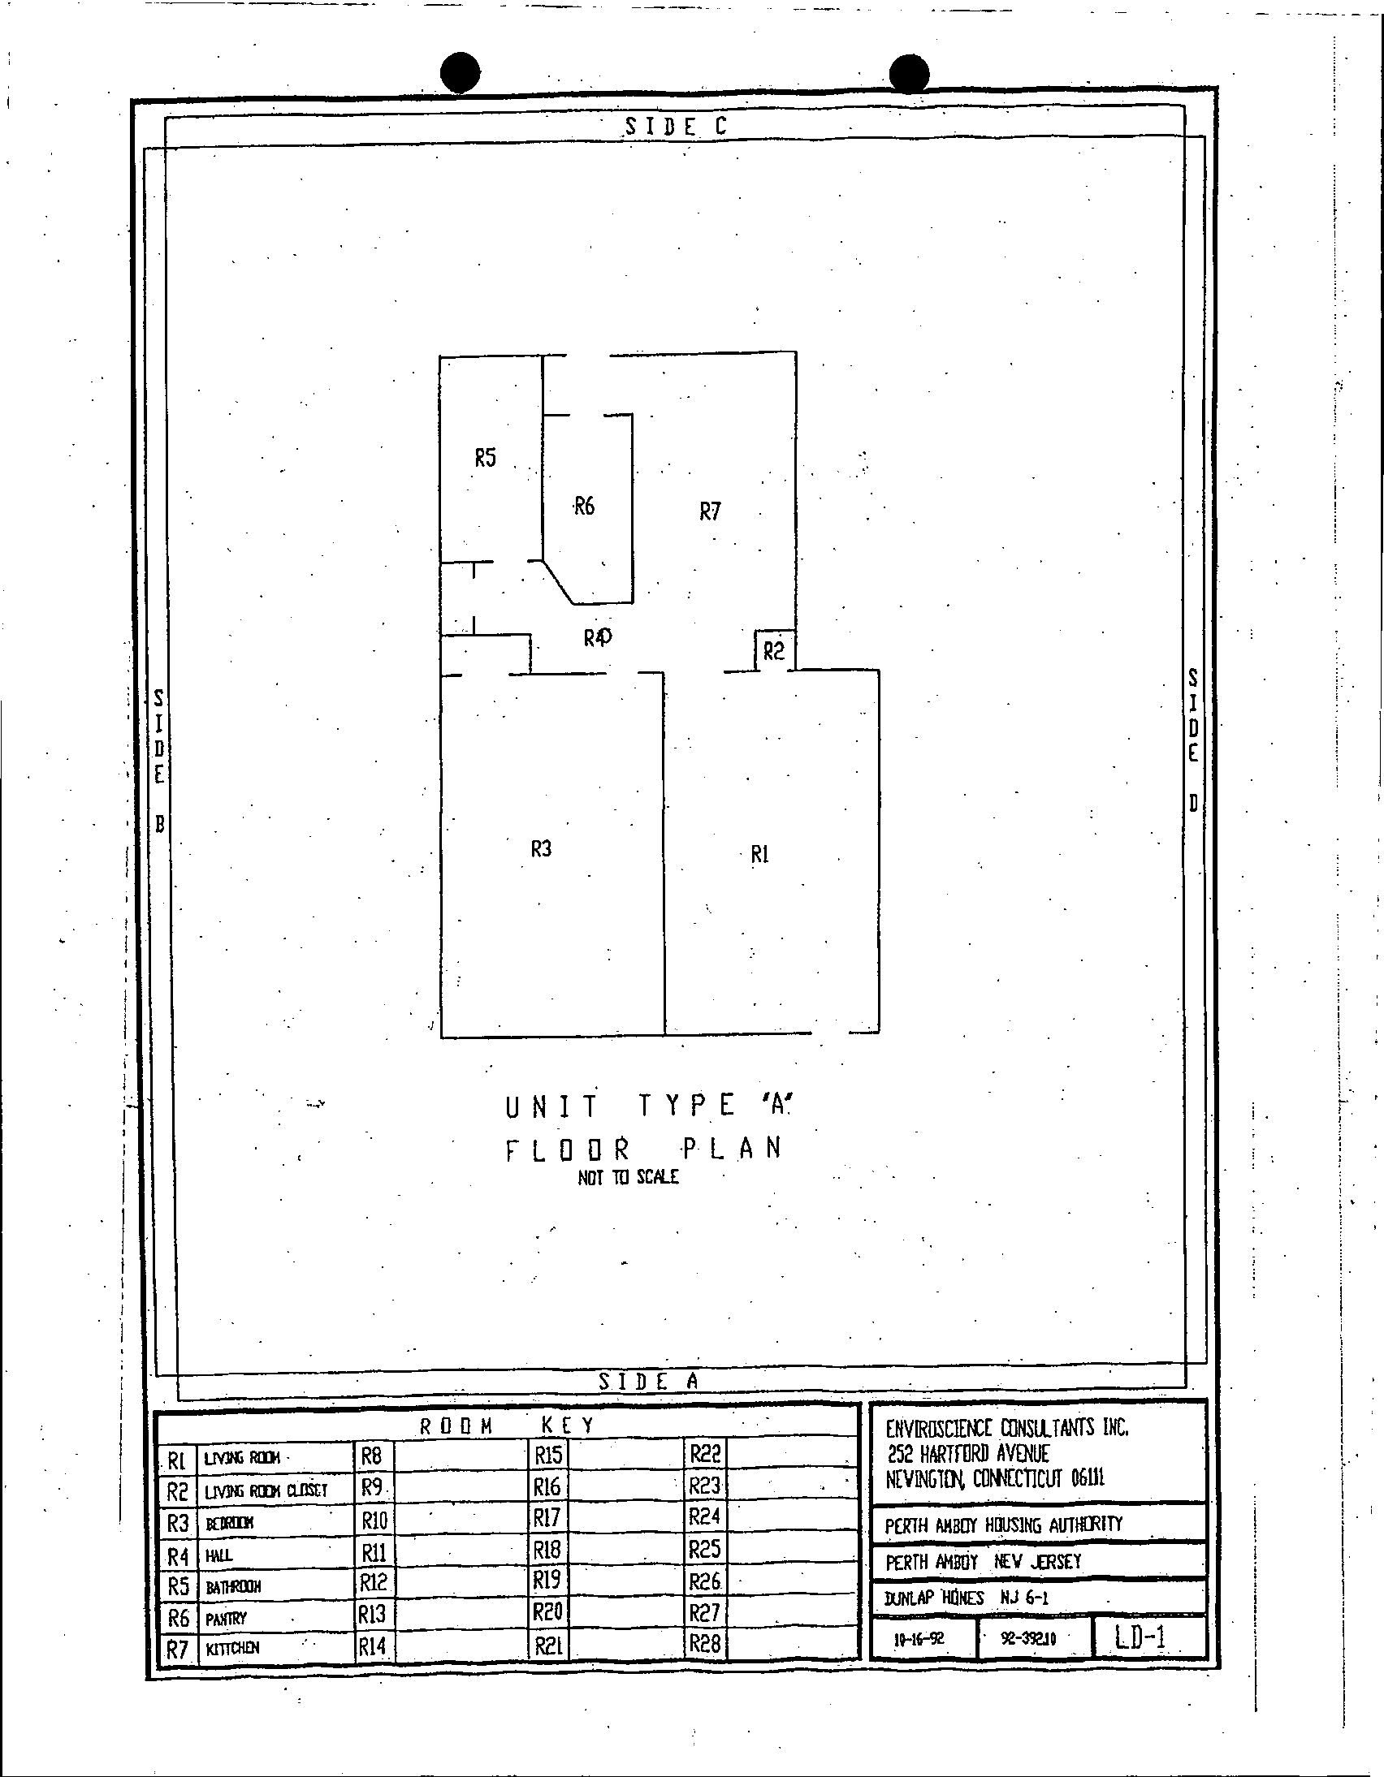

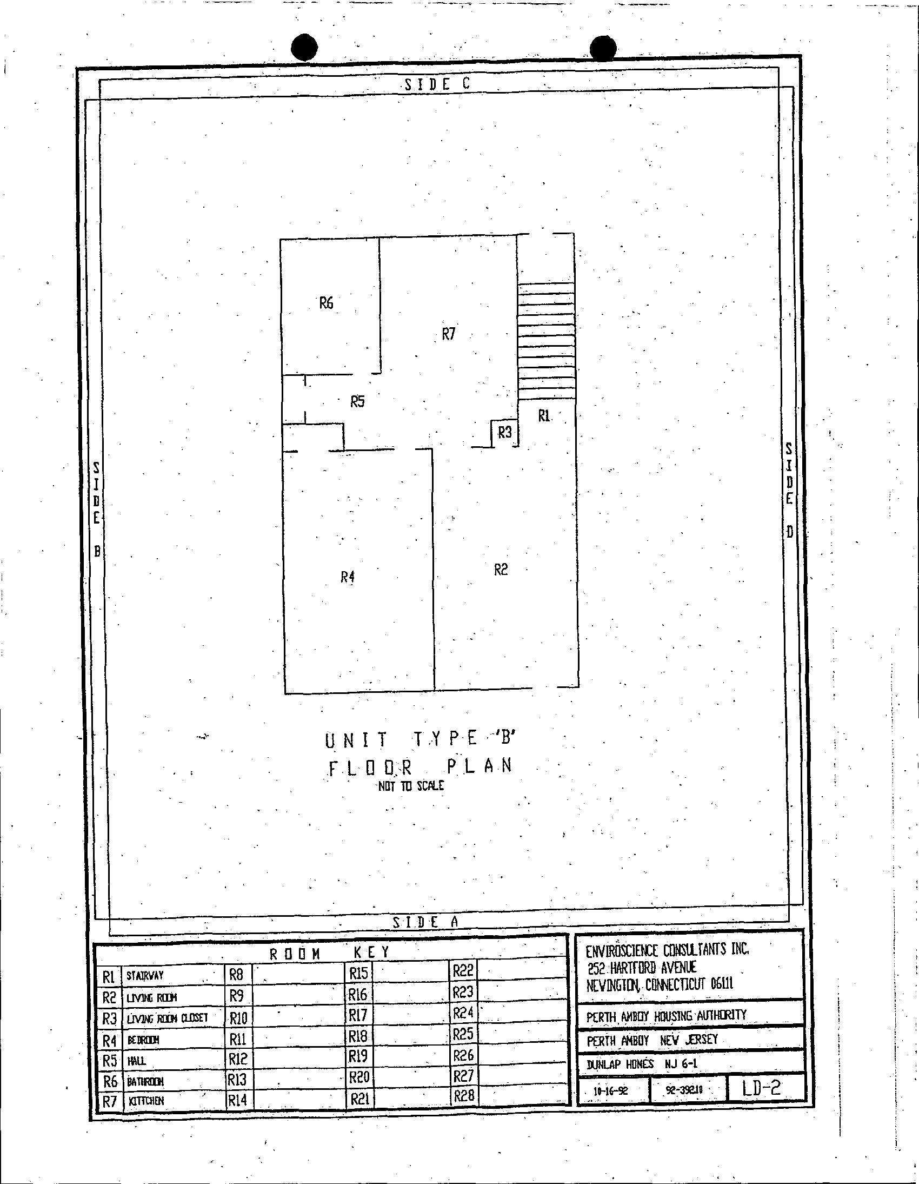

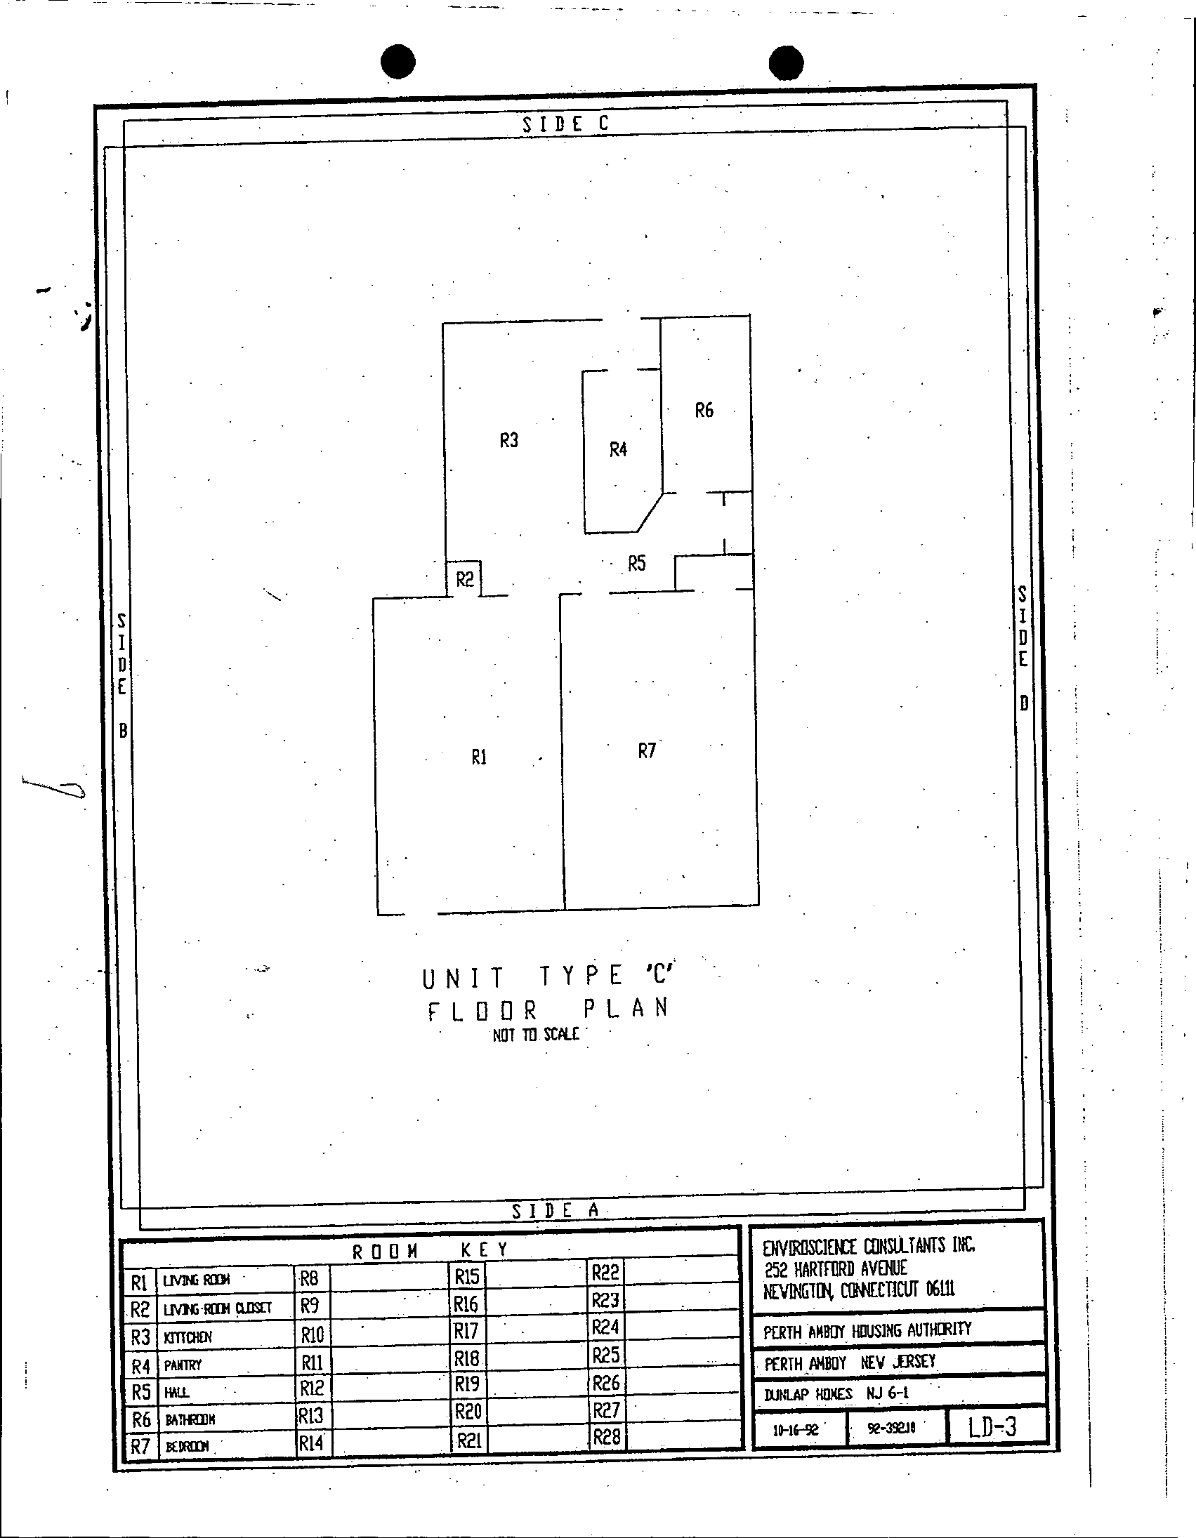

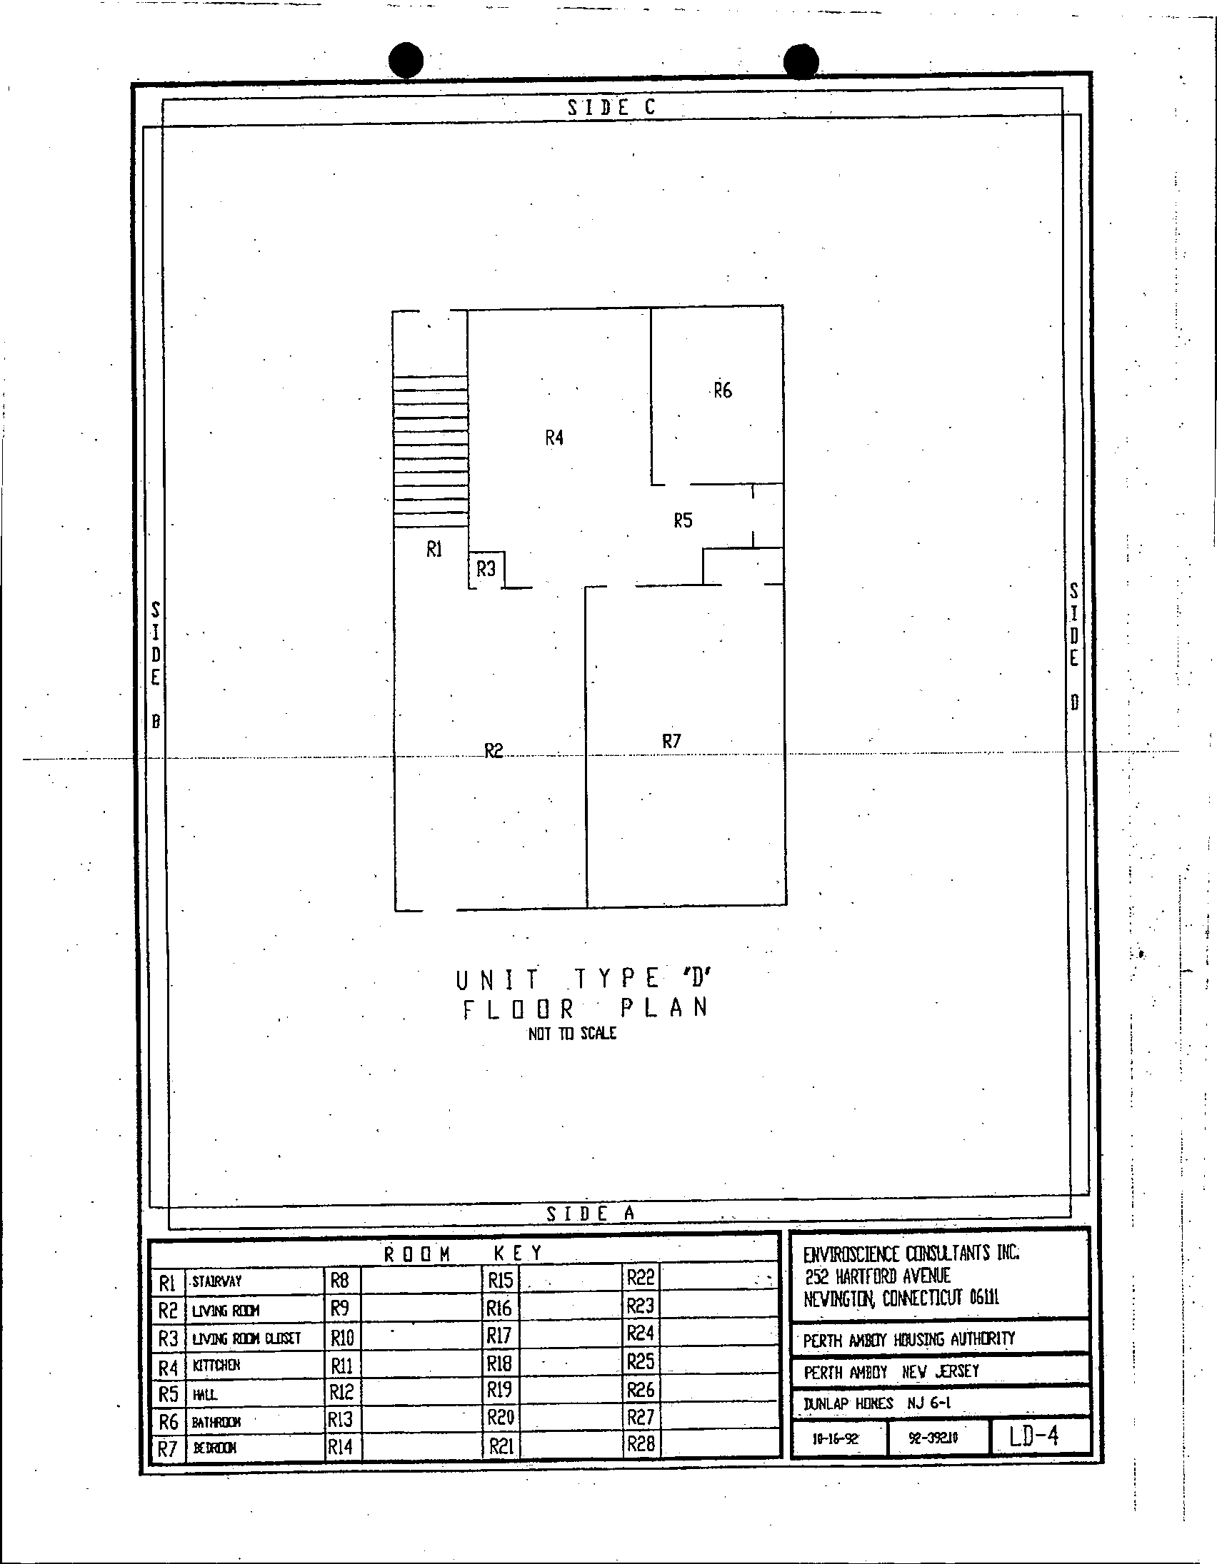

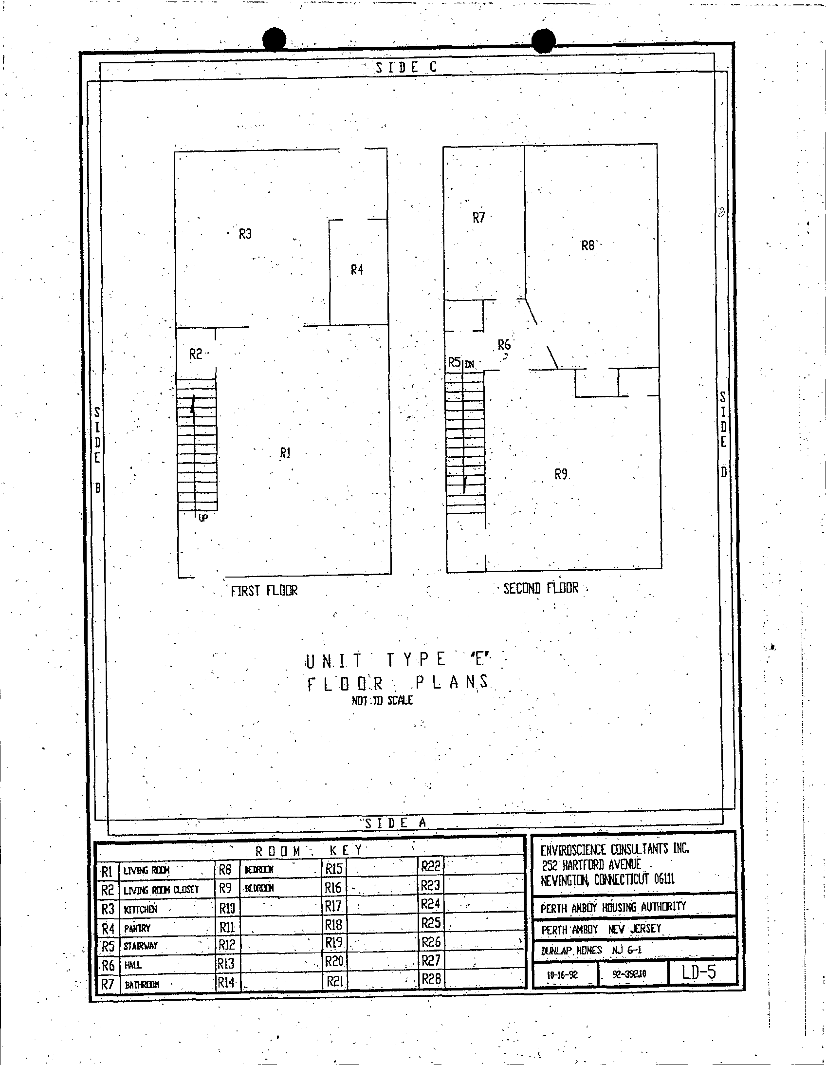

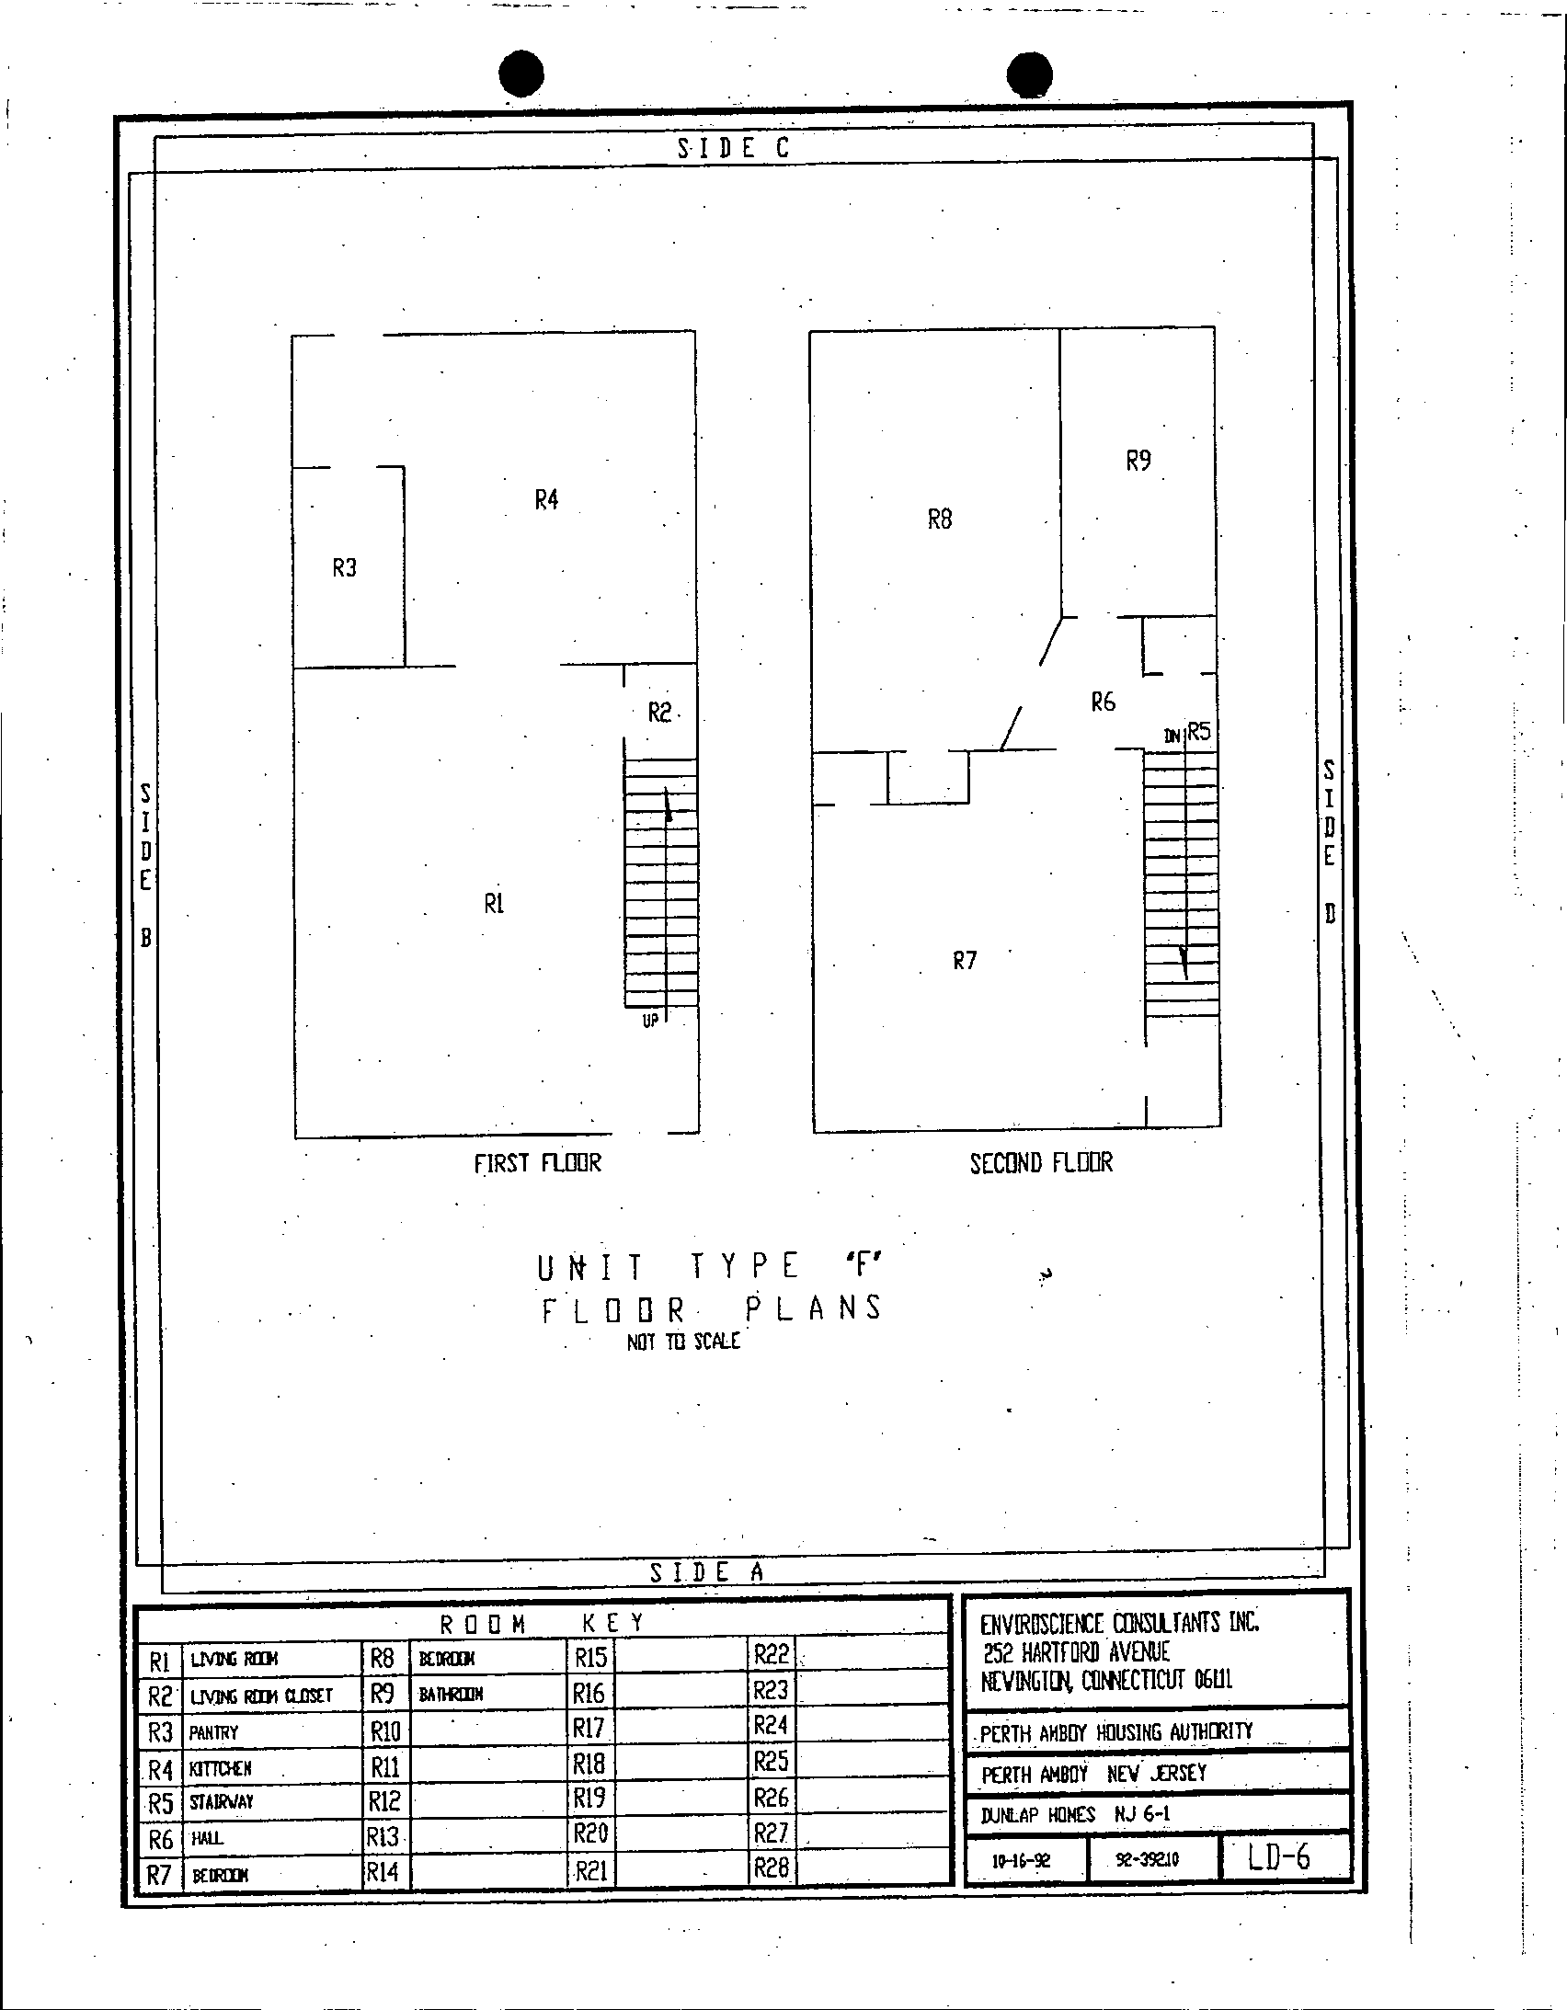

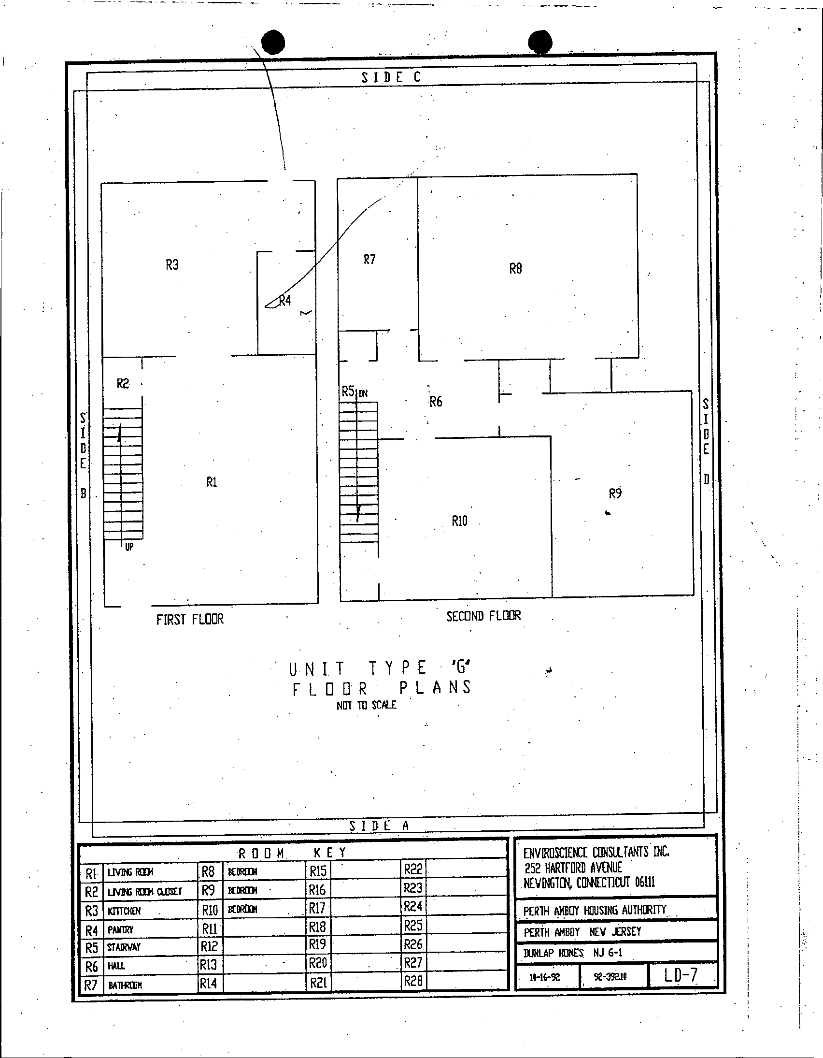

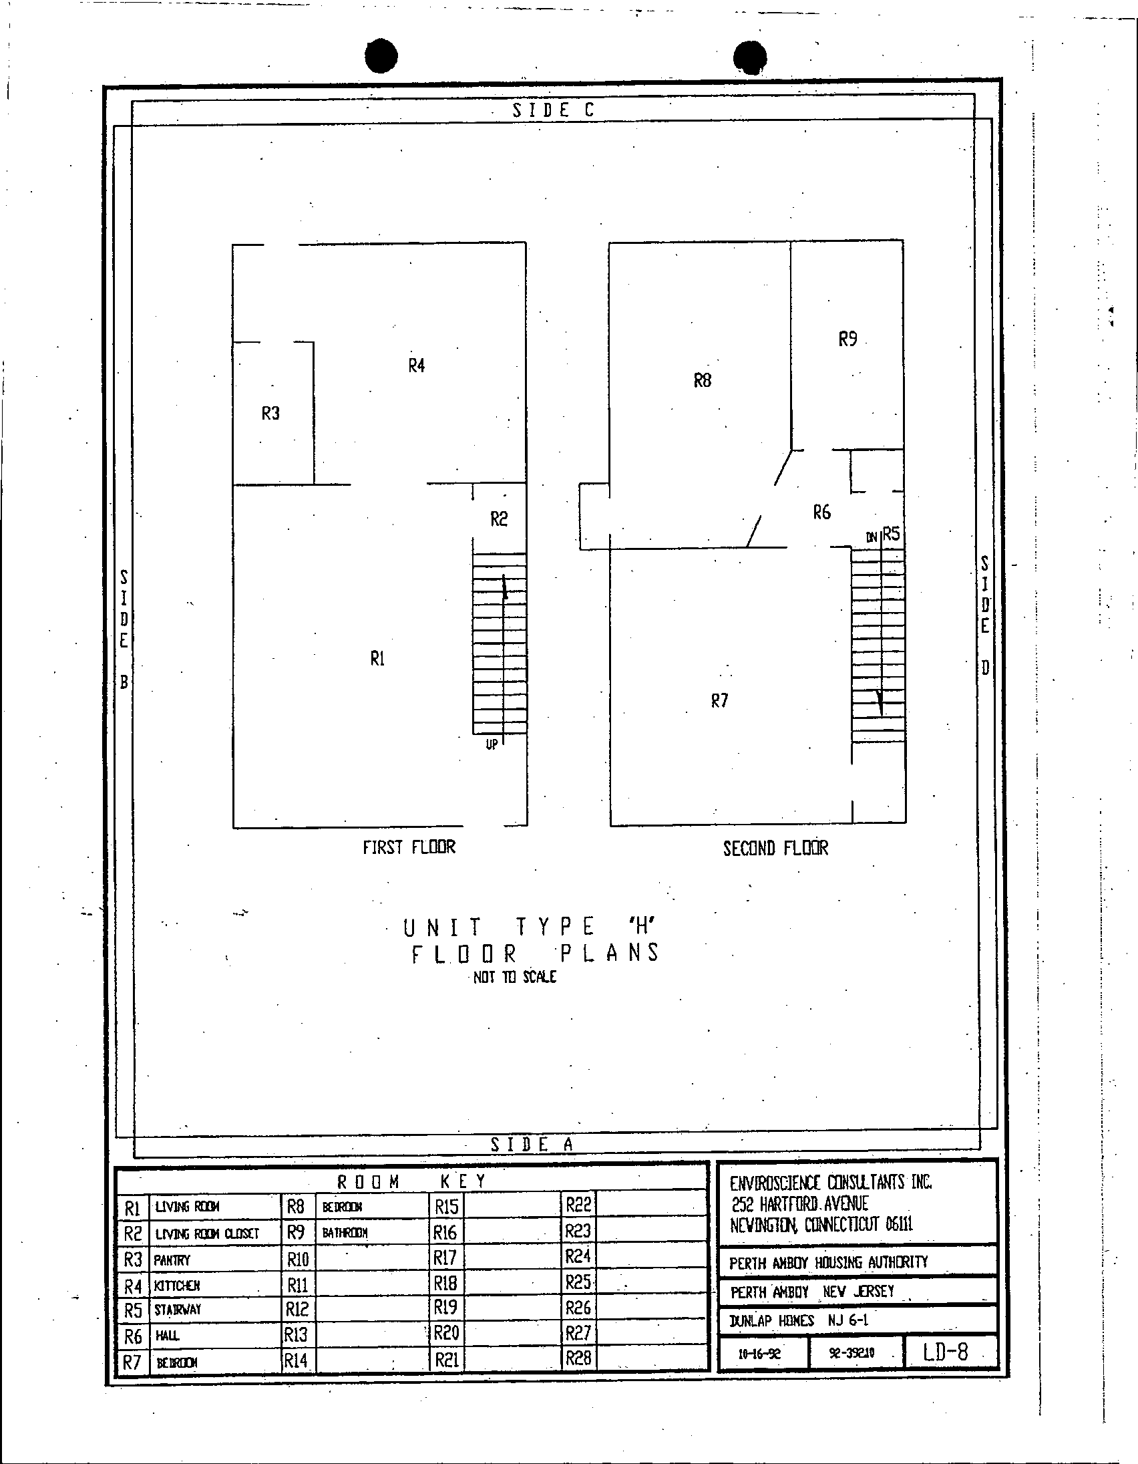

Proposal Form
Lead Based Paint Abatement at William A. Dunlap Homes
TO: Housing Authority of the City of Perth Amboy
881 Amboy Avenue, P.O. Box 390 Perth Amboy, NJ 08862
FROM:
____________________________________________________________________________________
Company Name of Bidder Federal ID# (FEIN or SS#)
____________________________________________________________________________________
Street Address
____________________________________________________________________________________
City, State - Zip Code
______________________________________________________________________________
Contact Name / Phone Number / Fax Number / Email Address

1. The undersigned, having read the Request for Proposals (RFP) and contract documents, and having investigated the local conditions affecting the cost of the work, hereby propose to furnish all labor, materials, services, equipment and related items to complete all work for lead-based paint abatement at William A. Dunlap Homes, Perth Amboy, NJ, including all items in the RFP and in accordance therewith, at the following costs:

A. Mobilization Cost
Mobilize crew, set up and take down containment, per apartment: $__________________

B. Lead based paint abatement by stripping and re-painting
Stairway risers and stringers: 10 risers, 3’-4” in width, per stair: $____________________
Stairway risers and stringers: 13 risers, 3’-0” in width, per stair: $____________________
Metal door frame, per frame: $____________________
Metal window sill, 6’-0” x 7”, per sill: $____________________
Metal window sill, 4’-6” x 7”, per sill: $____________________
Metal window sill, 3’ 0” x 7”, per sill: $____________________
Metal window frame: jambs and head 6’-0” x 4’-2” x 7”, per frame: $_________________
Metal window frame: jambs and head 4’-6” x 4’-2” x 7”, per frame: $_________________
Metal window frame: jambs and head 3’-0” x 4’-2” x 7”, per frame: $_________________
Metal baseboard, per lineal foot: $___________________
C. Lead based paint abatement by the enclosure method over existing wall surfaces.
Install gypsum board over existing plaster walls and concrete framing, tape, spackle caulk and paint, per square foot: $__________________

D. Removal and disposal of components having lead based paint.
Remove and dispose of existing plaster partition walls, per square foot: $___________________
Remove and dispose of interior doors, per door: $___________________

2. The offeror acknowledges the receipt of the following addenda, if any, issued by the Authority:

List addenda here: ______________________________ _____________________________

3. The names and address of persons interested as principals or as stockholders in this Proposal are as follows. (If the offeror is a corporation or partnership, list all persons who have 10 percent or more ownership in the corporation or partnership.) Add more sheets if necessary.

______________________________ ______________________________ ______________
Name Address % of Ownership
______________________________ ______________________________ ______________
Name Address % of Ownership
______________________________ ______________________________ ______________
Name Address % of Ownership

The offeror shall state on the line below, whether or not he is a citizen of the United States, and in the case of a partnership, whether or not all partners are citizens of the United States.

______________________________________________________________________________

4. This Proposal is accompanied by:
(1) Non-Collusive Affidavit;
(2) Qualification Questionnaire;
(3) Copy of New Jersey Business Registration Certificate
(4) Copy of the Contractors Public Works Contractor Registration Certificate

5. In submitting this proposal, it is understood that the Authority reserves the right to reject any and all offers. If written notice of the acceptance of this proposal is mailed, faxed or delivered to the undersigned within 60 days after the opening thereof, or at any time thereafter before this proposal is withdrawn, the undersigned agrees to execute and deliver a contract in prescribed form within 10 days after the contract is presented to him for signature.
AFFIDAVIT
State of ______________________________
SS.
County of ____________________________

________________________________ being first duly sworn deposes and says:
(Individual’s name)
THAT he is ___________________________________________________________________,
(Owner, Officer or Partner of the firm of etc.)
the party making the foregoing proposal for lead-based paint abatement services in William A. Dunlap Homes Perth Amboy, New Jersey; that all statements contained in this proposal are true, accurate and complete.

________________________________________________
(Signature of Offeror)
Subscribed and sworn to before me, this __ day of _____________, in the year ______
______________________________________________________
Notary Public
My Commission expires __________________
Non-Collusive Affidavit

AFFIDAVIT

State of ________________________________

County of ______________________________

_____________________________________________ being first duly sworn deposes and says:
(Individual’s Name)

THAT he is _________________________________________________________________ of
(Owner, Officer or Partner)

______________________________________________________________________________
(Firm Name)

the party making the foregoing proposal dated 9/18/25 for lead-based paint abatement services in William A. Dunlap Homes; that such proposal is genuine and not collusive or sham; that the offeror has not colluded, conspired, connived or agreed, directly or indirectly, with any offeror or person, to put in a sham proposal or to refrain from offering a proposal, and has not in any manner, directly or indirectly, sought by agreement or collusion, or communication or conference with any person, to fix the proposed prices of affiant or of any offeror, or to fix any overhead, profit or cost element of said proposed prices, or of that of any other offeror, or to secure any advantage against the Authority or any person interested in the proposed contract; and that all statements in the said proposal are true.

________________________________________________
(Signature of Offeror)

Subscribed and sworn to before me, this ____ day of _______________, in the year ________

____________________________________________________
Notary Public

My Commission expires __________________
Qualification Questionnaire

Proposal for: Lead-Based Paint Abatement Services in William A. Dunlap Homes

Name of Offeror: _______________________________________________________________

(a) How many years have you been or engaged in business under your present firm or trade name?
________ years.

(b) How many years has your organization been performing the work required under this contract?
________ years.

(c) If a corporation, answer the following:

Date of incorporation: ___________________________________________________________

State of Incorporation: ___________________________________________________________

President's Name: _______________________________________________________________

Vice President's Name(s):_________________________________________________________

______________________________________________________________________________

(d) If a partnership, answer the following:

Date of Organization:____________________________________________________________

(e) New Jersey Lead Abatement Contractor certification number and effective date:

______________________________________________________________________________

(f) List employees holding New Jersey Lead Abatement Supervisor certification and effective dates:

______________________________________________________________________________

______________________________________________________________________________

(g) If the contract is awarded to your firm, who will personally supervise the work?

______________________________________________________________________________

(h) Are there any liens of any character filed against your company at this time? If so, specify the nature and amount of the lien.

______________________________________________________________________________

(i) Give trade references:
______________________________________________________________________________

______________________________________________________________________________

(j) Give bank references:
______________________________________________________________________________

_____________________________________________________________________________

(k) Present a financial statement indicating the condition of your company of not more than 9 months prior to the bid submission.

(l) Have you ever failed to complete any work awarded to you? If so, state the circumstances.

______________________________________________________________________________
____________________________________________________________________________________________________________________________________________________________
(m) Give full information concerning all of your contracts in progress or completed within the last 3 years, whether private or government contracts.

OWNER/LOCATION DESCRIPTION CONTRACT AMOUNT

______________________________________________________________________________

______________________________________________________________________________

______________________________________________________________________________

State of ________________________

County of ______________________

_____________________________________________ being first duly sworn deposes and says:
(Individual’s Name)

THAT he is _________________________________________________________________ of
(Owner, Officer or Partner)
______________________________________________________________________________
(Firm Name)
and that he hereby authorizes and requests any person, firm or corporation to furnish any information requested by the Authority in verification of the recitals comprising this Statement of Offeror’s Qualification; and that all answers to the foregoing questions and all statements therein contained are true and correct.

________________________________________________
(Signature of Offeror)
Subscribed and sworn to before me, this ____ day of ________________, in the year _______
____________________________________________________
Notary Public
My Commission expires __________________

