Housing Authority of the City of Perth Amboy

881 AMBOY AVENUE, P.O. BOX 390, PERTH AMBOY, NJ 08862
TELEPHONE: (732) 826-3110
FAX: (732) 826-3111

EDNA DOROTHY CARTY-DANIEL, Chairperson DOUGLAS G. DZEMA, P.H.M.
FERNANDO A. GONZALEZ, Vice-Chairperson Executive Director
GREGORY PABON
MIGUEL A. AROCHO
DIANE CRAWFORD EDWARD TESTINO
DAVID BENYOLA Counsel
WILFREDO SOTO

REQUEST FOR PROPOSALS
for
BOILER AND HOT WATER HEATER
MAINTENANCE AND REPAIR SERVICES
at
William A. Dunlap Homes,
Richard F. Stack Apartments
and
Wesley T. Hansen Apartments

PERTH AMBOY, NEW JERSEY

Proposals due by 2:00 PM on July 23, 2024

CONTENTS

Introduction ……….…………………………………………………………………………… 3

Notice-Request for Proposals ………………………………………………..……..………….... 3

Instructions to Offerors, Non-Construction, form HUD-5369-B ….…………………………… 4-5

Form of Contract . ……..…………………..………………………...…….…………….......... 6-10

Description of the Housing Project Sites ………………………………………….……..………. 11

General Conditions for Non-Construction Contracts, form HUD-5370-C-II…………………. 12-14

Required Documents for Proposal:

Proposal Form ………………………..…………………………………....………….……….. 15-16

Non-Collusive Affidavit …………....……..……….…………………………………………… 17

Qualification Questionnaire ………...………………………………………..…………........... 18-19

Certifications and Representations of Offerors, Non Construction Contract ………...………… 20-21

PERTH AMBOY HOUSING AUTHORITY
REQUEST FOR PROPOSALS
BOILER AND HOT WATER HEATER MAINTENANCE AND REPAIR SERVICES

INTRODUCTION - The Housing Authority of the City of Perth Amboy (Authority) requests proposals from qualified contractors to perform boiler and hot water heater maintenance and as needed repair services at William A. Dunlap Homes, Richard F. Stack Apartments and Wesley T. Hansen Apartments located in, Perth Amboy, New Jersey. The resulting service contracts (two separate contracts as described herein) shall be for a two-year period, renewable at the agreement of both parties for one additional two-year period or two additional one-year periods at the agreement of both parties and at the same terms.

Sealed proposals will be received until 2:00 p.m. prevailing time on Tuesday, July 23, 2024, at the offices of the Authority, 881 Amboy Avenue, Perth Amboy, NJ 08861.

Contractors must have a minimum of 3 years’ experience and be registered with the State of NJ as a Public Works Contractor.

PUBLIC NOTICE – The following public notice was published in the Home News Tribune on 7/9/24 & 7/16/24:

Notice

Request for Proposals
Perth Amboy Housing Authority
Boiler and Hot Water Heater Maintenance and Repair Services

The Housing Authority of the City of Perth Amboy (Authority) will receive sealed proposals from qualified contractors to perform boiler and hot water heater maintenance and as needed repair services at William A. Dunlap Homes, Richard F. Stack Apartments and Wesley T. Hansen Apartments located in, Perth Amboy, New Jersey. The resulting service contract shall be for a two-year period, renewable at the agreement of both parties for one additional two-year period or two additional one-year periods at the agreement of both parties and at the same terms.

Sealed proposals will be received until 2:00 P.M. prevailing time on Tuesday, July 23, 2024 at the offices of the Authority, 881 Amboy Avenue, Perth Amboy, NJ 08861.

The written Request for Proposals (RFP) may be downloaded from Authority’s website at www.PerthAmboyHA.org. All contract requirements and requirements for the proposal are described in the RFP.

The Authority invites the participation of Minority-Owned Business Enterprises in this solicitation and reserves the right to reject any or all offers or to waive any informalities in this solicitation.

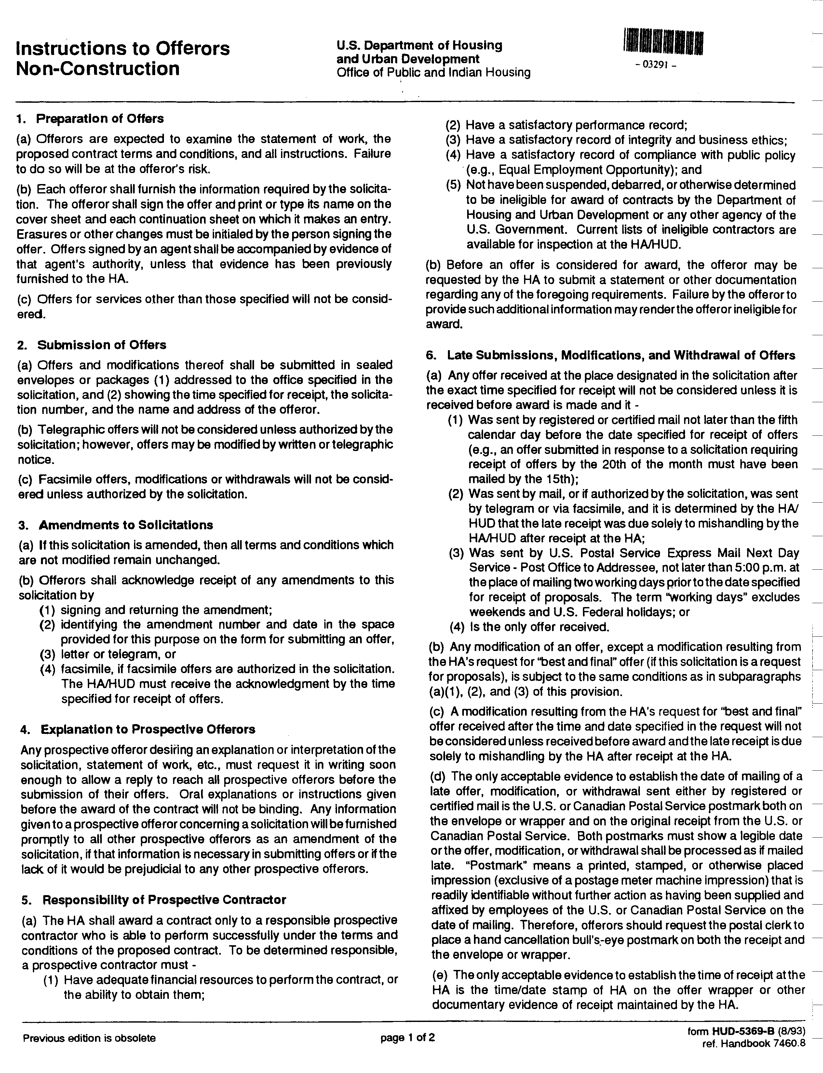
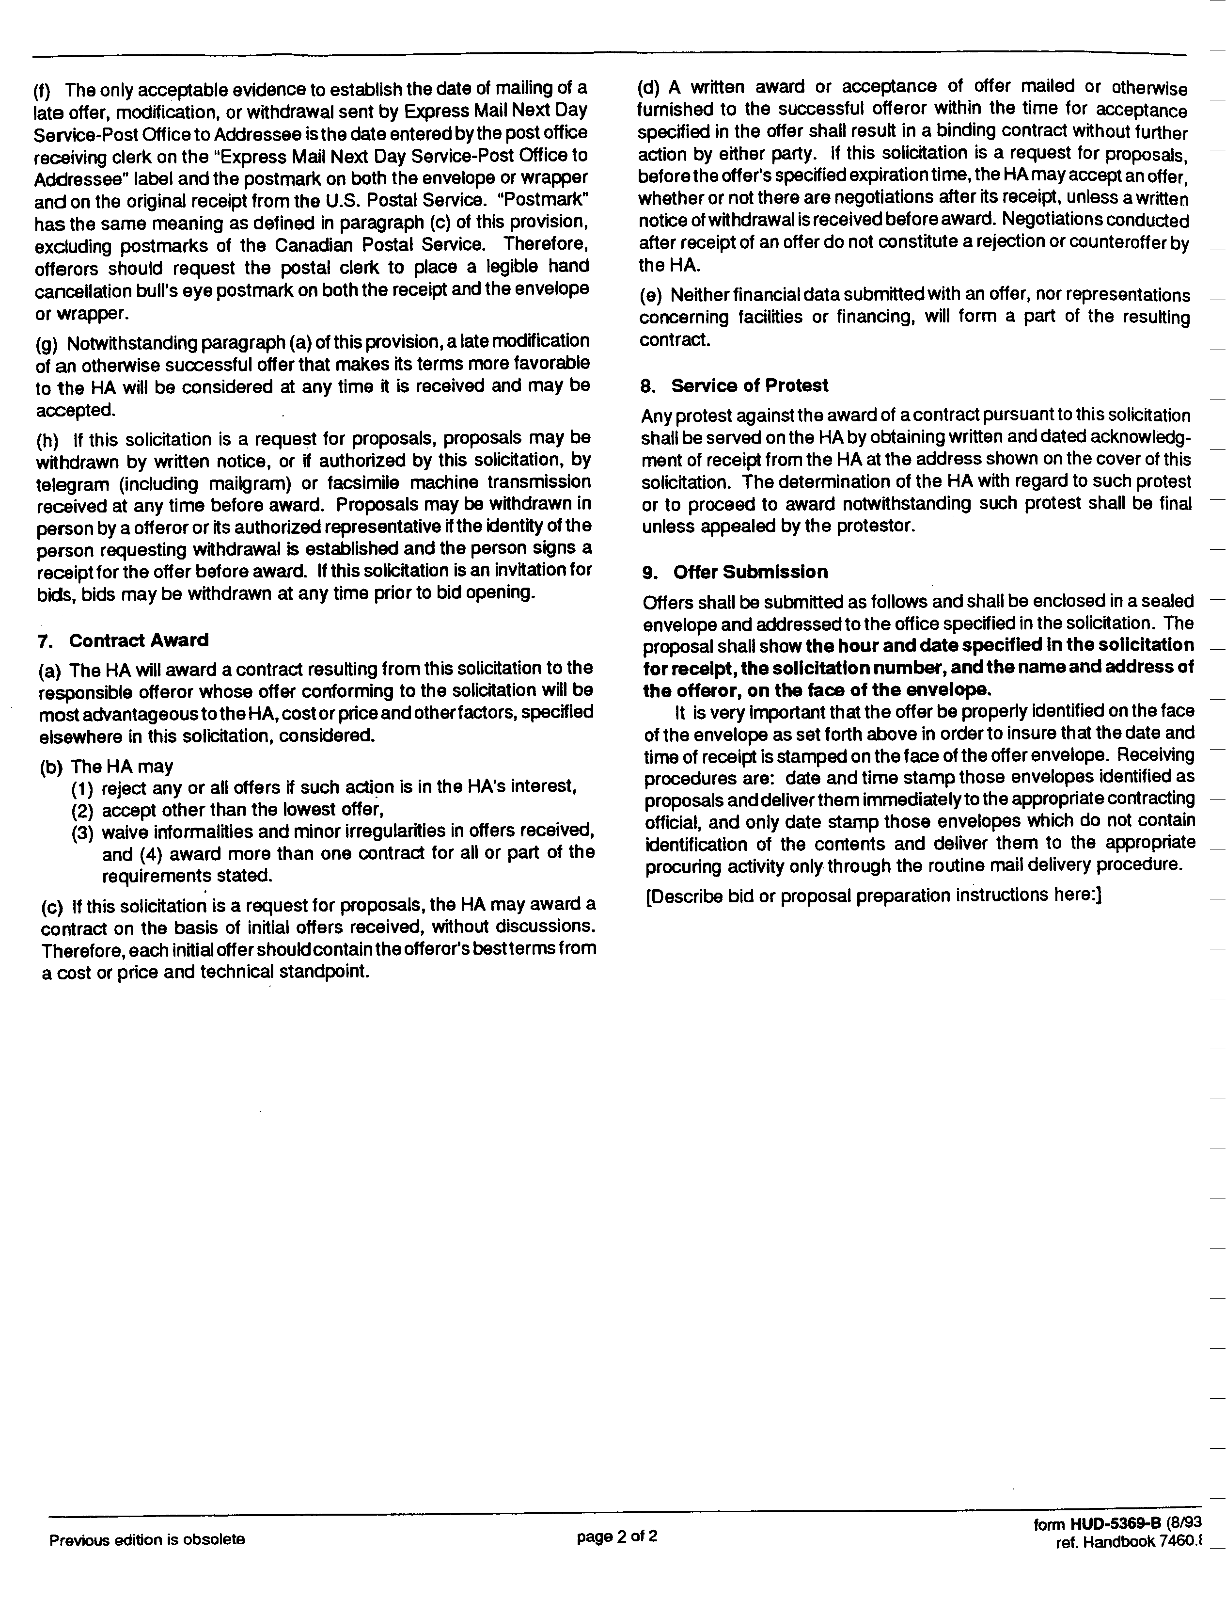

Form of Contract

For Boiler and Hot Water Heater Maintenance and Repair Services

This AGREEMENT made this 1st day of August in the year 2024 by and between

(Name of Contractor)
(Address)

hereinafter called the "Contractor,” and the
Two separate contracts shall be issued to one contractor
Housing Authority of the City of Perth Amboy (Dunlap RAD, LLC and Hansen RAD, LLC)
881 Amboy Avenue, P.O. Box 390, Perth Amboy, New Jersey 08862

hereinafter called the "Authority".

WITNESSETH that the Contractor and the Authority for the consideration stated herein mutually agree as follows:

Article 1. Statement of Services. The Contractor shall furnish all labor materials, tools and equipment and shall perform and complete all work required for maintenance and repair of boiler hot water heater and related equipment at William A. Dunlap Homes, located at Amboy Avenue and Zambory Street, Richard F. Stack Apartments, located at 333 Rector Street and Wesley T. Hansen Apartments, located at 415 Fayette Street, Perth Amboy, New Jersey.

The Contractor shall schedule and perform an annual start-up and maintenance service of the heating and hot water systems at all locations between September 1 and September 20 of each calendar year. The service shall include the following:

Dunlap Homes Service:
1. Hot Water Heaters:
a. Provide annual service as required by the manufacturer
b. Check combustible and exhaust venting, pumps, valves, safeties
c. Check all water and gas piping in boiler room for corrosions or
leaks.
2. Hydronic Boilers:
a. Provide for annual startup and service as required by the manufacturer. Clean filter
b. Check circulating pumps and lead lag pump control system.
c. Test low water cutoffs
d. Verify operation of Heat Timer Controls, 3-way valve, outdoor sensor and alarm functions.
e. Verify alarms with Central Station
f. Check al combustible and exhaust venting

Stack Apartments and Hansen Apartments Service: Provide for annual service of equipment and controls per the manufacturer’s instructions and not limited to:
- Test full operation of heating ands hot water equipment, including testing the controls and boiler firing sequence.
- Test all safeties as required under ASME VI Recommended Rules for the Care and Operation of Heating Boilers.
- Test all equipment and control systems per N.J.A.C. 12:90 and N.J.S.A.34:7-1 (6) Exception 6
- CBMS: Continuous Boiler Monitoring System: This control system operates the boilers, modulating, dampers and valves, steam valves, monitors the system safety interlocks and communicates alarms to a Central Station. This system shall be tested for function and operation including the communication and alarm side.
- Service contractor shall conduct startup and testing as follows:
    - Perform routine burner maintenance
    - Check all piping, fittings, vales for leaks.
    - Perform Combustion and draft tests. Check air intakes and outlets for blockages
    - Perform safety valve pop test
    - Slow drain test of low-water cutoff
    - Inspect gas piping
    - Check combustion control system
    - Inspect boiler room combustible and ventilation air intakes and louvers.
    - Inspect breeching and chimney.
    - Leak test all fuel valves.
    - Test and verify operations of CBMS control panels.
    - Test operations of boiler alarm panel and CBMS communications: coordinate with Central Station
    - Clean/replace flapper valves
    - Lubricate the modulation motor arms, gas and exhaust butterfly valves.
    - Remove low water cut off probe and clean. Replace the probe in the boiler.
    - Remove the float from the water level control by removing the bolts from the flange. Clean any dirt or sediments from the bowl and glass.
    - Remove the sight glass and clean.
    - Perform purge procedure as outlined by Fulton Heating Solutions, Inc.
    - Perform startup procedure as outlined by Fulton Heating solutions, Inc.
- Boiler parts and instrumentation shall be replaced with OEM parts unless approved otherwise by the HA.
- All work shall be performed in strict adherence to the Codes and Standards adopted in the rules and regulations N.J.A.C. 12:90 and Exception 6 governing a Continuous Boiler Monitoring system.

Article 2. Performance of Repair Work. The Authority shall have the sole right and discretion to order work under his contract The Authority reserves the right to award work of a similar nature, through other procurement methods, to other contractors.

Repairs shall be performed by the Contractor on an as-needed basis. The Authority makes no representation as to the amount of work that may be required during the contract period.

The Authority shall notify the Contractor of all work to be performed by means of a written work order. The Contractor shall be entitled to a minimum payment of two (2) hours labor charges for each completed work order. Labor charges shall be calculated based upon actual time spent at the housing project work site. No charges shall be made for travel or shop time. Fractions of hours shall be rounded up to the next hour.

Typically, work shall be performed during the Authority’s standard business hours. However, the Contractor shall be available to respond to emergency work order requests during non-business hours.

The Contractor may perform or complete non-emergency work orders outside of standard business hours for the Contractor’s convenience only if the Authority grants prior permission. For work performed under such circumstance, the Contractor will be compensated at the standard labor rates stated in Article 5 below.

The Contractor shall respond to an emergency work order within twenty-four (24) hours of the receipt of written notification and shall respond to a non-emergency work order within seventy-two (72) hours of written notification.

The Contractor shall be equipped to perform the work with all tools and equipment ordinarily and incidentally used in the performance of commercial piping and electrical installations and repairs. If specialized equipment is required to perform a work order, the Contractor shall so notify the Authority. The Contractor shall obtain the Authority’s approval for the use and applicable charges for such equipment prior to the Contractor’s commencement of the work order or the Contractor’s procurement of equipment.

The Authority, at its discretion, may request an estimate from the Contractor of the labor and materials required to perform a work order. Estimates shall be provided at no cost to the Authority.

Upon completion of each work order, the Contractor shall present the completed written work order, indicating the actual time spent and materials used, to a designated representative of the Authority.

Article 3. Work Requirements and Contractor’s Responsibility. The Contractor shall be responsible for furnishing all materials, equipment, labor and transportation necessary to perform the inspection maintenance and repair services.

All work shall be performed in accordance with federal, State, County and local statutes, regulations and codes presently established or as may be established during the term of this contract. If the Contractor performs any work contrary to any federal, State, County or local statute, ordinance, regulation or code, he shall assume full responsibility and shall bear any and all costs attributable thereto.

The Contractor shall be responsible to apply for and secure any and all permits required by governing authorities to perform the work.

All workers employed by the Contractor to perform electrical work must work under the direct supervision of a licensed electrician.

Laborers shall not be permitted to perform any electrical work, piping, installation of valves, controls or any other components.

The Contractor shall be responsible for all materials delivered and work performed until completion and acceptance of each work order.

The Contractor shall not sub-contract any work under this contract without express prior written approval of the Authority.

The Contractor shall at all times keep the work area orderly and free from accumulations of waste materials. After completing each work order, the Contractor shall remove all equipment materials and tools that are not the property of the Authority and leave the work area in a neat, clean and orderly condition.

The Contractor shall be responsible for all damages to persons or property that occur as a result of the Contractor’s fault or negligence, and shall take all necessary health and safety precautions to protect the work, the workers, the public, and the property of others. The Contractor shall hold and save the Authority, its officers and agents, free and harmless from liability of any nature occasioned by the Contractor’s performance.

Article 4. Payments and Labor Rates for Repair Services.

The Authority shall pay the Contractor for the start-up and maintenance services at all sites a fixed price (stipulated sum) of _______________________ dollars and ________ cents ($______.____).

The Authority shall pay the Contractor for repair work at the rates shown below. The rates shall be inclusive of all costs for labor, tools and equipment. The Authority shall also reimburse the Contractor for the actual cost of materials and approved specialized equipment plus a mark-up of ten percent (10%) of these costs.

The Authority shall pay the Contractor for work performed during the Authority’s business hours, Monday to Friday, 7:00 a.m. to 4:30 p.m., exclusive of holidays, at the following rates.

Standard Labor Rates

Plumber/Pipefitter: ________________________ dollars and ________ cents ($__. __) per hour.
Electrician: ______________________________ dollars and ________ cents ($__. __) per hour.
Laborer: ________________________________ dollars and ________ cents ($__. __) per hour.

The Authority shall pay the Contractor for work performed at all other times at the following rates, unless work is performed at such times for the Contractor’s convenience.

Premium Labor Rates:

Plumber/Pipefitter: ________________________ dollars and ________ cents ($__. __) per hour.
Electrician: ______________________________ dollars and ________ cents ($__. __) per hour.
Laborer: ________________________________ dollars and ________ cents ($__. __) per hour.

The Housing Authority shall make payments upon the completion of work by the Contractor, including the filing of required reports, and the presentation of an invoice. Invoices for repairs must be accompanied by a completed work order signed by a representative of the Authority, and paid receipts for any material and approved specialized equipment costs. Payment shall be due within 30 days of receipt of the invoice by the Housing Authority.

Article 5. Term of Contract. This contract shall extend for a period of two years, August 1, 2024 through July 30, 2026, and shall be renewable for one additional two-year period or two additional one year periods at the mutual agreement of both parties and at the same price and labor rates stated in Article 4 above.

Article 6. Insurance. Before performing any work, the Contractor shall furnish the Authority with certificates of insurance showing the following insurance is in force and will insure all operations under the Contract:
- Workers’ Compensation, in accordance with New Jersey Workers' Compensation laws.
- Commercial General Liability with a combined single limit for bodily injury and property damage of not less than $2,000,000.00 per occurrence to protect the Contractor and the Authority against claims for bodily injury or death and damage to the property of others. This shall cover the use of all equipment, hoists, and vehicles on the site(s) not covered by Automobile Liability under (3) below. If the Contractor has a “claims-made” policy, then the following additional requirements apply: the policy must provide a “retroactive date” which must be on or before the execution date of the Contract, and the extended reporting period may not be less than five years following the completion date of the Contract.
- Automobile Liability on owned on owned and non-owned motor vehicles used on the site(s) or in connection therewith for a combined single limit for bodily injury and property damage of not less than $500,000.000 per occurrence.

All Insurance shall be carried with companies which are financially responsible and admitted to do business in the State of New Jersey. If any such insurance is due to expire during the construction period, the Contractor shall not permit the coverage to lapse and shall furnish evidence of coverage to the Authority. All certificates of insurance, as evidence of coverage, shall provide that no coverage maybe canceled or non-renewed by the insurance company until at least 30 days prior written notice has been given to the Housing Authority.

Article 7. New Jersey Business Registration Requirements. The contractor shall provide to the Authority proof of the contractor’s business registration with the New Jersey Division of Taxation before contract award and shall provide written notice to its subcontractors and suppliers of the responsibility to submit proof of business registration to the contractor.

A business organization that fails to provide a copy of a business registration as required pursuant to section 1 of P.L. 2001, c.34 (C.52:32-44 et al.) or subsection e. or f. of section 92 of P.L. 1977, c.110 (C.5:12-92), or that provides false business registration under the requirements of either of those sections, shall be liable for a penalty of $25 for each day of violation, not to exceed $50,000 for each business registration copy not properly provided under a contract with a contracting agency.

Article 8. Contract Documents. Contract Documents shall consist of the following component parts:
- This instrument;
- General Contract Conditions for Non Construction Contracts, form HUD-5370-C II; and
- Addenda (if any).

This instrument together with the document enumerated in this Article form the Contract, and they are fully a part of the Contract as if hereto attached or herein repeated. In the event that any provision in one of the component parts of the Contract conflicts with any provision of any other component part, the provision in the component part first enumerated in this Article 8 shall govern, except as otherwise specifically stated.

IN WITNESS WHEREOF, the parties hereto have caused this instrument to be executed the date and year first above written.

In the presence of:
____________________________________ by_______________________________________

(Name)
(Title)
(Company Name)
In the presence of:

_____________________________________ by______________________________________
Douglas G. Dzema, PHM
Executive Director
Housing Authority of the
City of Perth Amboy

Description of the Housing Project Sites and Boiler and Hot Water Heaters

TO BE BILLED SEPARATELY AS HANSEN RAD, LLC
Development Name: William A. Dunlap Homes
Address: Amboy Avenue & Zambory Street, Perth Amboy, NJ
Buildings: 17 Residential Two-Story Brick Row House
Boilers and Hot Water Heating Equipment:
Bldg A:
Boiler: One (1) LAARS, Pennant PNCH0750
Hot Water Heater: One (1) Bradford White EF100T199E3N2
Bldg. B & C:
Boilers: One (1) each building LAARS, Pennant PCNH0500
Hot Water Heaters: One (1) each building Bradford White EF100T150E3N2
Bldg. D:
Boiler: One (1) LAARS Pennant PCNH0300
Hot Water Heater: One (1) Bradford White EF100T150E3N2
Bldg. F.
Hot Water Heaters: Three(3) Lochinvar CFN751PM

TO BE BILLED SEPARATELY AS DUNLAP RAD, LLC
Development Name: Richard F. Stack Apartments
Address: 333 Rector Street, Perth Amboy, NJ
Building: 1 Residential Six-Story Elevator Building
Boilers and Hot Water Heating Equipment:
Six (6) Fulton Model PVLP1150 Vertical Low Pressure Steam boilers,
1.15mil BTU each.
Controls: Preferred Instruments Model MCS-CDHOHOA-61
Venting: Draft Induced, Exhausto Model EBC30w/VFD

Development Name: Wesley T. Hansen Apartments
Address: 415 Fayette Street, Perth Amboy, NJ
Building: 1 Residential Eleven-Story Elevator Building
Boilers and Hot Water Heating Equipment:
Three (3) Fulton Pulse Pak PHW2000, 2million BTU each
Burner: Power Flame Model WCR3-GO-25
Controls: Preferred Instruments Model MCS-CDHOAXX-31
Venting: Draft induced, Exhausto Model EBC30 w/VFD

All items of equipment at all sites are natural gas-fired.

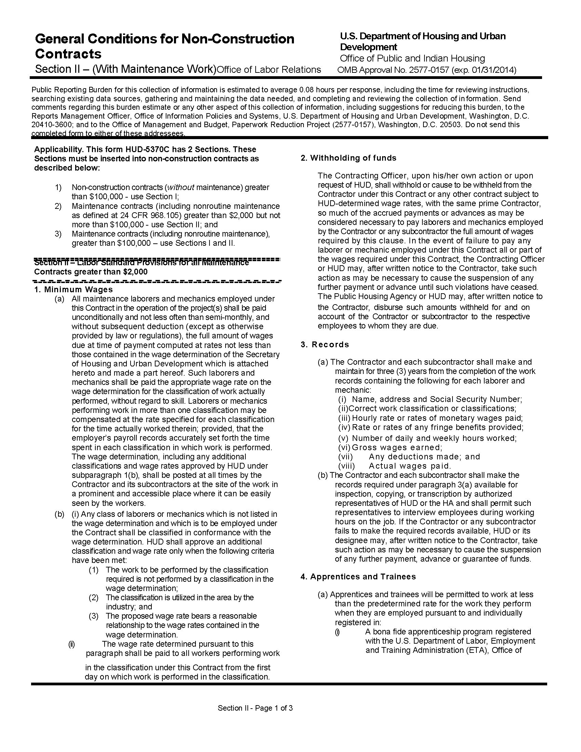

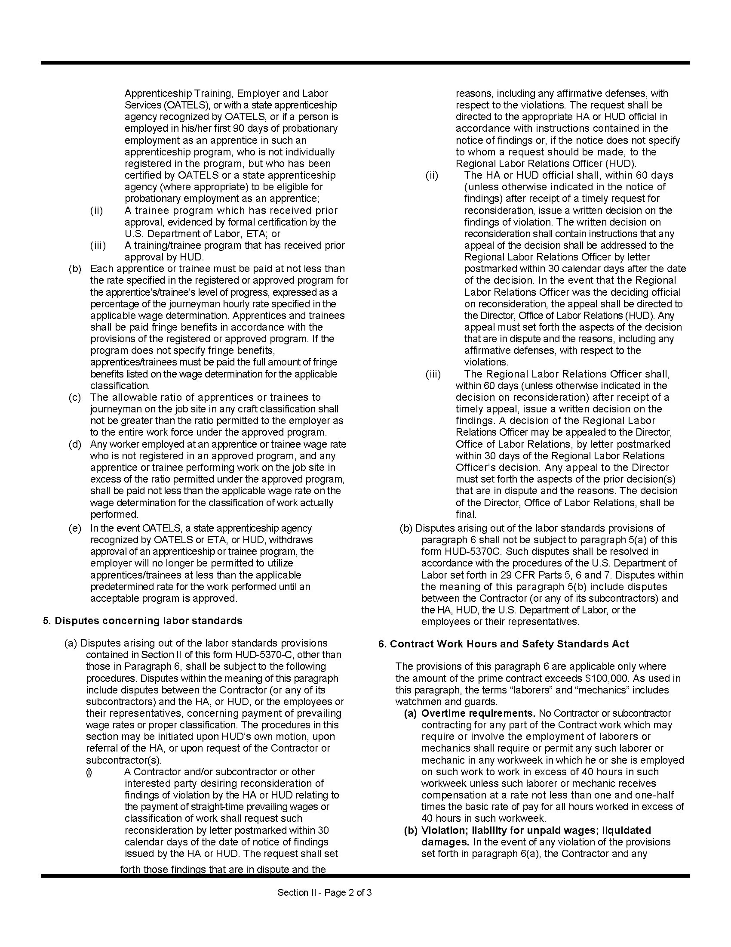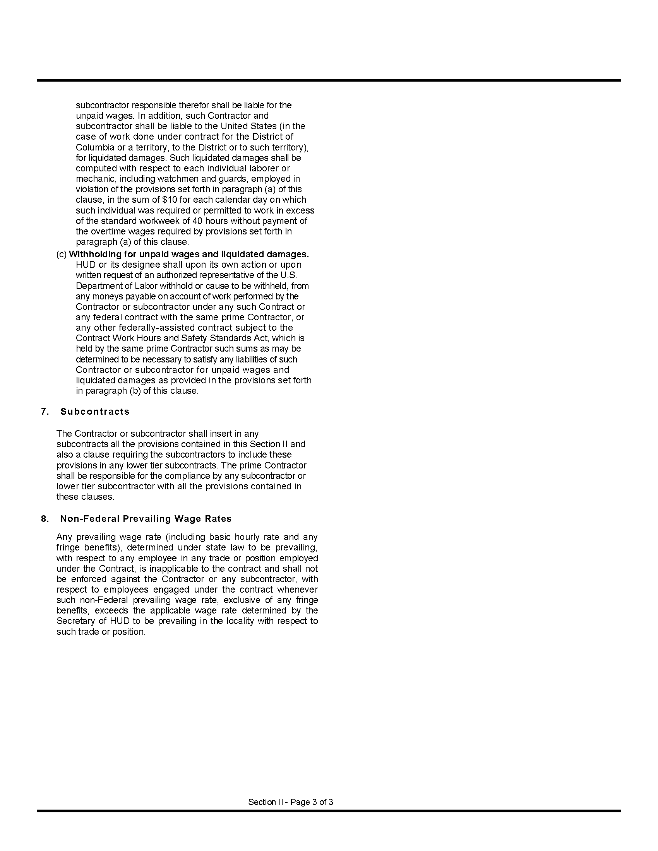

Proposal
Proposal for: Boiler and Hot Water Equipment Maintenance and Repair Services

TO: Housing Authority of the City of Perth Amboy
881 Amboy Avenue, P.O. Box 390, Perth Amboy, NJ 08862

FROM:
______________________________________________________________________________
Company Name of Bidder Federal ID Number (FEIN or SS#)
______________________________________________________________________________
Street Address
______________________________________________________________________________
City, State - Zip Code
______________________________________________________________________________
Contact Name / Telephone Number / Fax Number / Email Address

1. The undersigned, having read the specifications, including the Request for Proposals, the form of contract, contract conditions, description of the project sites and equipment, this proposal form, the form of non-collusive affidavit, the form of statement of bidder's qualifications, the Certifications and Representations of Offerers, and addenda, if any, thereto, and having investigated the local conditions affecting the cost of the work, hereby propose to furnish all labor, materials, services, equipment and related items to complete all work for boiler and hot water equipment maintenance and repair services at William A. Dunlap Homes, Richard F. Stack Apartments and Wesley T. Hansen Apartments in accordance therewith at the following fixed price and labor rates for repair services:

Annual Maintenance Services at Hansen and Stack Apartments, Fixed Price:
__________________________________________________dollars and _______ cents ($_______.___)
Annual Maintenance Services at Dunlap Homes, Fixed Price:
__________________________________________________dollars and _______ cents ($_______.___)
APPLICABLE TO ALL SITES:
Plumber/Pipefitter, Standard Rate:
______________________________________________dollars and _______ cents ($___.___) per hour.
Laborer, Standard Rate:
______________________________________________dollars and _______ cents ($___.___) per hour.
Plumber/Pipefitter, Premium Rate:
______________________________________________dollars and _______ cents ($___.___) per hour
Laborer, Premium Rate:
______________________________________________dollars and _______ cents ($___.___) per hour.
2. The names and address of persons interested as principals or as stockholders in this Proposal are as follows. (If the offerer is a corporation or partnership, list all persons who have 10 percent or more ownership in the corporation or partnership.)

______________________________________________________________________________
Full Name Address % of ownership
______________________________________________________________________________
Full Name Address % of Ownership
______________________________________________________________________________
Full Name Address % of ownership

The offerer shall state on the line below, whether or not he is a citizen of the United States, and in the case of a partnership, whether or not all partners are citizens of the United States.

____________________________________________________________________________________

4. This Proposal is accompanied by:

(1) Non-Collusive Affidavit;
(2) Qualification Questionnaire;
(3) Form HUD-5369-C, Certifications and Representations, of Offerors, Non-Construction Contract;

Note: Failure to submit any of the documents listed above will disqualify the proposal.
It is recommended that the documents below be submitted with the proposal. In any case, these documents must be submitted to the Authority before a contract may be awarded.

(4) Copy of New Jersey Business Registration Certificate issued by the New Jersey Department of the Treasury, Division of Revenue (this certificate must be effective on the date specified for receipt of proposals (5/15/19). The Certificate of Authority to collect New Jersey sales & use tax, issued by the New Jersey Department of the Treasury, Division of Taxation is NOT an acceptable substitute for this document.

(5) Copy of Certificate of Public Works Contractor Registration issued by the New Jersey Department of Labor.

5. In submitting this proposal, it is understood that the Authority reserves the right to reject any and all proposals. If written notice of the acceptance of this proposal is mailed, telegraphed or delivered to the undersigned within 60 days after the receipt thereof, or at any time thereafter before this proposal is withdrawn, the undersigned agrees to execute and deliver a Contract in prescribed form within 10 days after the contract is presented to him for signature.

AFFIDAVIT

State of ______________________________
SS.
County of ____________________________

________________________________ being first duly sworn deposes and says:
(Individual’s name)

THAT he is ___________________________________________________________________,
(Owner, Officer or Partner of the firm of etc.)

the party making the foregoing proposal for boiler and hot water heater maintenance and repair services at Dunlap Homes, Stack Apartments and Hansen Apartments in Perth Amboy, New Jersey; that all statements contained in this proposal are true, accurate and complete.
________________________________________________
(Signature of Bidder)

Subscribed and sworn to before me, this ____ day of ____________________ in the year _____.

________________________________________________
Notary Public
My Commission expires _________________________
Date

Non-Collusive Affidavit

AFFIDAVIT

State of ________________________

County of ______________________

___________________________________________________ being first duly sworn deposes and says:
(Individual’s Name)

THAT he is ________________________________________________________________________ of
(Owner, Officer or Partner)

____________________________________________________________________________________
(Firm Name)

the party making the foregoing proposal dated July 23, 2024 for boiler and hot water heater maintenance and repair services; that such proposal is genuine and not collusive or sham; that the offerer has not colluded, conspired, connived or agreed, directly or indirectly, with any offerer or person, to put in a sham proposal or to refrain from offering a proposal, and has not in any manner, directly or indirectly, sought by agreement or collusion, or communication or conference with any person, to fix the price of affiant or of any offerer, or to fix any overhead, profit or cost element of said price, or of that of any other offerer, or to secure any advantage against the Housing Authority of the City of Perth Amboy or any person interested in the proposed contract; and that all statements in the said proposal are true.

________________________________________________
(Signature of Offerer)

Subscribed and sworn to before me, this ______ day of _________________, in the year ___________

____________________________________________________
Notary Public

My Commission expires __________________

Qualification Questionnaire

Proposal for: Boiler and Hot Water Equipment Maintenance and Repair Services

Name of Offerer: ______________________________________________________________________

Address:_____________________________________________________________________________

____________________________________________________________________________________

(a) It shall be necessary for the offerer to present evidence that he has been in business for at least 3 years in this field and can submit a suitable record of satisfactorily completing similar contracts.

How many years have you been or engaged in business under your present firm or trade name?
________________Years.

(b) How many years has your organization been performing the work required under this contract?

________________Years.
(c) If a corporation, answer the following:

Date of incorporation: __________________________________________________________________

State of Incorporation: __________________________________________________________________

President's Name: _____________________________________________________________________

Vice President's Name(s):_______________________________________________________________

(d) If a partnership, answer the following:

Date of Organization:___________________________________________________________________

(e) If applicable, list New Jersey Master Plumber or Electrical Contractor License(s) and effective dates:

____________________________________________________________________________________

(f) List any employees holding New Jersey Plumber or Electrician registrations and effective dates:

____________________________________________________________________________________

____________________________________________________________________________________

(g) If the contract is awarded to your firm, who will personally supervise the work?

____________________________________________________________________________________

(h) Are there any liens of any character filed against your company at this time? If so, specify the nature and amount of the lien.

____________________________________________________________________________________

(i) Give trade references:
____________________________________________________________________________________

____________________________________________________________________________________

(j) Give bank references:
____________________________________________________________________________________

____________________________________________________________________________________

(k) Give full information concerning all of your contracts in progress or completed within the last 3 years, whether private or government contracts.

OWNER/LOCATION DESCRIPTION CONTRACT AMOUNT

____________________________________________________________________________________

____________________________________________________________________________________

____________________________________________________________________________________

State of ________________________

County of ______________________

___________________________________________________ being first duly sworn deposes and says:
(Individual’s Name)

THAT he is ________________________________________________________________________ of
(Owner, Officer or Partner)

____________________________________________________________________________________
(Firm Name)
and that he hereby authorizes and requests any person, firm or corporation to furnish any information requested by the Housing Authority of the City of Perth Amboy in verification of the recitals comprising this Statement of Qualifications; and that all answers to the foregoing questions and all statements therein contained are true and correct.

________________________________________________
(Signature of Offerer)

Subscribed and sworn to before me, this ______ day of _________________, in the year ___________

____________________________________________________
Notary Public

My Commission expires __________________
